Greek and Latin lessons boost reading and maths skills
- NICOLA WOOLCOCK
- THE TIMES
- 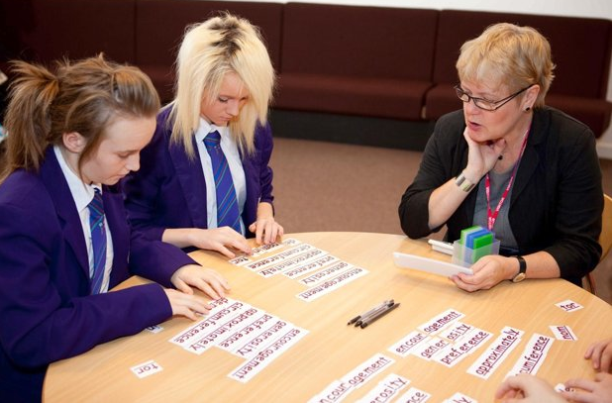
Children are making years of progress in just a few weeks by learning to break down words using Latin and Greek.
A program that borrows from the classics is giving pupils who have fallen behind their classmates a huge boost in deciphering English and even helping with maths and science.
Some children have advanced by six years in as many weeks, by using the technique to decode words and broaden their vocabulary, research has found.
Pupils learn dozens of prefix, stem and suffix meanings, most originating from Greek or Latin, so they can work out what words mean, or can have an educated guess.
Research at Northumbria University found that children made, on average, 27 months of progress, but one school reported a small group improving their reading age by six years. Exam results have risen, not only in English but also other subjects, because children are more confident with terminology.
In the sessions, right, pupils faced with unknown words are taught how to analyse them and look for familiar syllables. They are given timed challenges to encourage them to improve quickly.
Examples include bio meaning “life” in Greek, giving clues to the meaning of biography, biology and symbiotic; dict meaning “to say” in Latin, as in dictation, predict and contradict; and dis meaning “not” or “not any” from the Latin, as in disbelief and disrespect.
Children also learn that anthrop is the Greek root for “human” (anthropomorphic, anthropology), and chron is Greek for “time” (chronic, synchronise), among many others.
The technique was developed by Katy Parkinson, a former home economics teacher who ended up working in a pupil referral unit and became concerned by the poor quality of materials. After years spent honing the lessons, she was on the verge of giving up when people began taking notice. Her Sound Training system has now been used in about 500 schools.
Teachers spend one hour a week for six weeks with a handful of pupils. Mrs Parkinson said: “Some children had been able to read words but didn’t have a clue what they meant. In one school, children thought ‘minority’ meant ‘bad’, because they’d been told a minority of pupils had been naughty.
“They all knew what ‘minor’ meant but hadn’t made the connection between that and ‘minority’. There’s a lot of confusion out there. Latin petered out in schools because it was considered useless. This is a modern version of Latin and Greek because we need those systems, especially as we have so many children coming from language-starved backgrounds.”
Mrs Parkinson said that the training helped children in subjects other than English, for example remembering the difference between perpendicular and parallel lines in maths, because pend means “hang” in Latin.
Robert Bradley, the assistant head teacher at Brynmawr Foundation School near Abergavenny, said: “The biggest difference we’ve seen is in pupils’ confidence, in all of their subjects. Their attainment has improved as they are more capable of accessing the curriculum.
“We’ve seen big improvements in national reading tests and other exam results. We see an average improvement in reading age of 35 months through Sound Training, but this has been up to five or six years for some.”
Jennie Hick, the vice-principal of Mounts Bay Academy in Cornwall, said she put pupils on the course who had problems with literacy, but also those needing a boost to reach the next step.
She said. “We also target some of our top students who are looking to apply to Oxbridge and the red-brick universities, working on the expansion of vocabulary. Students who could previously struggle with attendance became engaged in lessons again, because they were able to understand the meaning behind what was being taught.”
The Times

