Ammonia Synthesis
The following diagram is taken from a film about ammonia production, which can be downloaded from the internet site
www.rsc.org/education/teachers/learnnet/alchemy/index2.htm
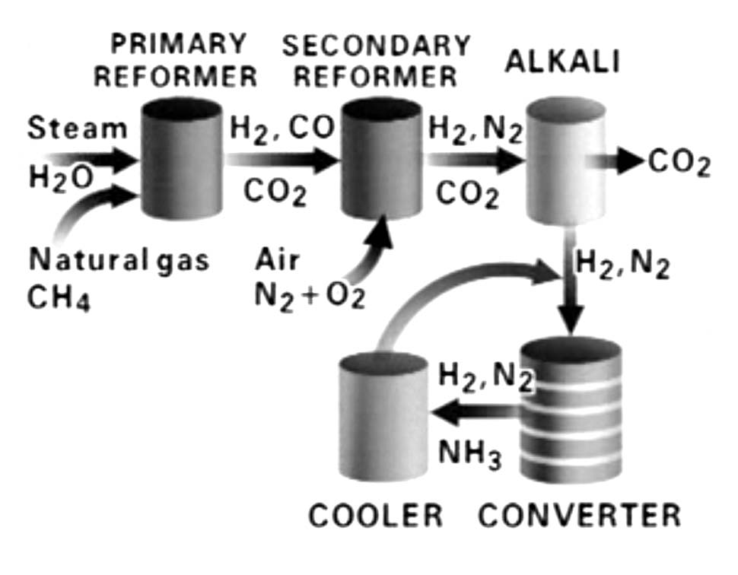
1.) Watch the film, then write down the reaction equations for the reactions taking place in the
a) primary reformer (2 reactions)
b) secondary reformer (2 reactions)
c) converter (1 reaction)
2.) How does the constant removal of ammonia in the cooler influence the equilibrium in the converter?

