**Effects of Changing Conditions  
on the Chemical Equilibrium  
(Self-study Module)**

How do chemical equilibria behave, when conditions like concentration, pressure or temperature change? This self-study module provides the answer.

**1. The effect of changes in concentration**

In the experiment described below, you will mix dilute solutions of **iron(III) nitrate** and **potassium thiocyanate**.

**Problem 1:** Which ions are contained within these solutions? Give their formulae and names.

Dissolved iron(III) ions and thiocyanate ions combine to form a so-called complex. A complex consists of a positive ion (= central ion), surrounded by dipole molecules or anions (so-called ligands), fixed to the central ion through electrical attraction[1]. In this way, the following equilibrium materialises in the mixture of both solutions:

**Fe3+(aq) + 3 SCN–(aq) Fe(SCN)3(aq)**



Fe(SCN)3 is a soluble iron(III) thiocyanate complex.

**Problem 2:**

a) Write down the law of mass action for the abovementioned equilibrium.

b) If the system is taken out of equilibrium by adding more Fe3+ ions to the solution, a new equilibrium state will materialise in a short time. How does this happen? Answer this question using the law of mass action.

c) Show, using the law of mass action, how the system reacts to an increase of the SCN– concentration.

d) What would happen if some of the iron ions were removed from the solution?

Now you will check your predictions experimentally.

**Experiment: influencing the equilibrium with concentration changes**

You need the following resources :

• Safety glasses

• Tissues

• Spatula

• 2 Pasteur pipettes

• 7 test tubes & test tube rack

• 2 measuring cylinders (50 ml)

• Gas burner & matches

• Deionised water

• Aqueous solutions:

• Fe(NO3)3 (0.004 mol/l)

• KSCN (0.008 mol/l)

• Sunset yellow[2] (1 g/l)

• Solid substances: Fe(NO3)3, KSCN, NaH2PO4

**Pay attention to the following:**

• Work in pairs.

• Wear **safety glasses** during the whole experiment (also when washing up!).

• Do not in any way contaminate the chemicals in the containers. Therefore:

• Use a different pipette for each solution. **Do not mix up the pipettes!**

• **Clean your spatula** immediately and thoroughly after use with paper.

• Close the containers immediately after use (do not mix up the lids!).

• Wipe away any chemical splashes immediately with a paper towel.

• Write down your observations.

• You should always know what you're doing - and why.

**Proceed as follows:**

1.) Measure out 15 ml of each reactant solution in a measuring cylinder by pouring from the bottle and then adjusting with a pipette. Then mix both solutions in one measuring cylinder and ensure that it is well mixed.

2.) What colours are the reactants and products of the resulting reaction? Remember that nitrate ions are colourless.

3.) Pour into 6 test tubes each about one sixth of the amount of solution. The **first** test tube acts as a reference (so that you have the colour of the unchanged solution in front of you). In the other 5 test tubes, you will change the equilibrium in steps 4 to 9.

4.) Add a small spatula tip's worth *(not a heaped spatula!)* of Fe(NO3)3 to the **second** test tube and shake it to mix well. Does the observed change agree with the answer from problem 2?

5.) What change do you expect once some SCN- is added?

6.) Add a small spatula tip's worth of KSCN to the **third** test tube and shake. Is your prediction confirmed?

7.) NaH2PO4 and Fe3+ form a precipitate of iron phosphate. Hence what do you expect after adding a small spatula tip's worth of NaH2PO4? Check this in the **fourth** test tube.

8.) Sunset yellow is an organic dye which remains chemically unchanged in an aqueous solution. It has more or less the same colour as the iron thiocyanate complex. Pour into the empty (**seventh**) test tube about as much of the sunset yellow solution as there is solution in the **fifth** test tube. The colouring in both (the fifth and the seventh) test tubes should be about the same[3]. Now dilute the contents of both these test tubes with deionised water to give about 4 times the original volume. What do you observe? How do you explain your observation (using the law of mass action)?

9.) So we still have the **sixth** test tube. Warm it *gently* with the burner while shaking (do not boil). How does the temperature influence the equilibrium constant?

10.) Cleaning up:

• Pour the contents of the test tubes down the sink. Quickly rinse the test tubes, measuring cylinders and pipettes (without the rubber part) with tap water and put them into the used glassware box beside the sink.

• Put away all the rest of the material where you got it from (after cleaning it well!).

**2. Le Châtelier’s Principle: the effects of changes in concentration, pressure and temperature**

The effects of concentration, pressure and temperature on the position of a chemical equilibrium can be qualitively described by Le Châtelier’s Principle: **“If a chemical system in equilibrium experiences changes to the external conditions (concentration, pressure, temperature), then the equilibrium shifts to minimise the imposed change."**

**Change of concentration:**

As an example, we will use the reaction you experimented with:

Fe3+(aq) + 3 SCN–(aq) Fe(SCN)3(aq)



How does an **increase in a reactant’s concentration** influence the position of the equilibrium? The only way the system can minimise the imposed change (i.e. the reactant’s concentration increase) is to use up reactants by transforming them into products. This means, that for a while the forward reaction is faster than the reverse reaction, so that the reactant’s concentration decreases. As a consequence, the forward reaction slows down and due to the product concentration increase, the reverse reaction rate increases until it becomes equal to the forward reaction rate. After a while - be it nanoseconds or milleniums - the forward and reverse reaction rate will be equal: a new equilibrium has been established. It’s product concentration is higher than in the former equilibrium state: we say that it's position hasundergone a so-called **“shift to the right side (the product side)”**.

**Problem 3:** show by using Le Châtelier’s Principle to which side the equilibrium shifts when:

a) The concentration of a reactant is decreased.

b) The concentration of product is increased.

You could also have solved this problem using the law of mass action. Regarding concentration changes, Le Châtelier’s Principle is just another tool but doesn’t provide additional possibilities. In contrary, the law of mass action also gives a quantitative (not only a qualitative) description of the equilibrium, which can be used to calculate equilibrium concentrations. If you like to use Le Châtelier's Principle or the law of mass action to solve qualitative problems on **concentration** changes is your choice. The same is true for the description of the effects of **pressure** changes on equilibrium, which you will get to know right in the following section.

However, the law of mass action gives no information about the effects of **temperature**. As we will abstain from looking at the mathematical description of the temperature dependence of equilibrium, you need Le Châtelier’s Principle to determine the effects of temperature changes; examples will follow later on.

**Change of pressure:**

The influence of pressure changes are only relevant to equilibria, in which gases are involved, since liquids and solids are virtually incompressible. With gases,an increase of the pressure results in an increase of the concentration. In physics lessons, you learn that the product of the pressure and the volume of a gas under constant temperature is constant (Boyle’s and Mariotte’s law). Doubling the pressure results in halving the volume and therefore doubling the concentration. In this way, the effects of pressure changes can be defined using the **law of mass action**.

How to assess the pressure dependence of an equilibrium using **Le Châtelier’s Principle** is shown in the following example:

2 NO2(g) N2O4(g)



NO2 is a brown gas, N2O4 a colourless gas; therefore shifts in equilibrium can be identified by colour changes.

How can the system minimise an **increase in pressure**? According to Avogadro’s Law, the volume of a gas is proportional to the number of its molecules. Thus, more molecules need more space - or, if the volume can’t be increased, they exert a higher pressure. If the number of gas molecules is different on the reactants’ and products’ side, the system can minimise an increase in pressure by **shifting to the side with less gas molecules**.

**Problem 4:**

a) How does the equilibrium between NO2 and N2O4 change as a result of a pressure increase? How does it change with a pressure decrease?

b) Sparkling wine, beer and cola all contain dissolved carbon dioxide. When you open a bottle of such a drink, bubbles appear in the liquid; if you close the bottle again, the bubble build-up stops. Explain this phenomenon. The equilibrium to be considered is

CO2(aq) CO2(g).



c) For many industrial syntheses, so-called synthesis gas (a mixture of CO and H2)is needed. It is produced by passing superheated steam over glowing coke[4] through the following endothermic reaction:

H2O(g) + C(s) H2(g) + CO(g)



What effect does a pressure increase have on the equilibrium?

**Change of temperature:**

Equilibrium constants are temperature dependent. Whether an equilibrium constant becomes larger or smaller with increasing temperature can be determined using Le Châtelier’s Principle: An **increase in temperature** constitutes a change which the system can minimise by a heat consuming (endothermic) reaction. If this is the forward reaction, an increase in temperature will shift the equilibrium to the right; if the forward reaction is exothermic (and hence the reverse reaction endothermic), the shift will be to the left. In any case, the equilibrium **shifts to the side with the substances richer in energy.** - Of course a temperature decrease has the opposite effect.

**Problem 5:**

a) The conversion from NO2 to N2O4 is exothermic. To which side does the equilibrium shift by heating, and likewise by cooling the reaction mixture?

b) What effect does a temperature decrease have on the amount of product in equilibrium during the manufacture of synthesis gas (cf. problem 4 c)?

c) Does the equilibrium constant of an equilibrium with an exothermic forward reaction increase or decrease with increasing temperature?

d) Is the formation of a complex of Fe3+ and SCN– exothermic or endothermic? Remember your experiments!

**3. Ammonia Synthesis**

Elemental nitrogen (N2), which is abundant in the atmosphere, is not suitable as a nitrogen source for the synthesis of organic nitrogen compounds. Also plants are not able to use it; to build up nitrogen compounds (e.g. proteins), they need nitrate ions which they take up with the soil water. The reason for this is the **inertness of the N2 molecule,** which normally only reacts at high temperatures.

Therefore, the industrial conversion of atmospheric nitrogen into **ammonia (NH3)** is of vast significance. Ammonia is much more **reactive** than elemental nitrogen because of its polar bonds. It can be used to produce fertiliser: ammonium salts, nitrates (after conversion of the ammonia to **nitric acid)** and urea (by the reaction of ammonia with carbon dioxide). Around 80% of the worldwide production of ammonia (which is over 100 million tons per year) is used for fertilizer production. Ammonia and nitric acid also serve as a **nitrogen source for organic syntheses**, e.g for synthetic fibres and explosives. The following graph shows ammonia usage in percent of the worldwide production.

To synthesise ammonia, besides nitrogen **hydrogen** is needed. It is normally produced by chemical conversion of natural gas (methane), with CO2 as a by-product. Alternatively, it could be produced by electrolysis of water, but this is not profitable at present, and an ecological advantage would only result if the necessary electrical energy would not be produced by fuel combustion as is the case in most countries.

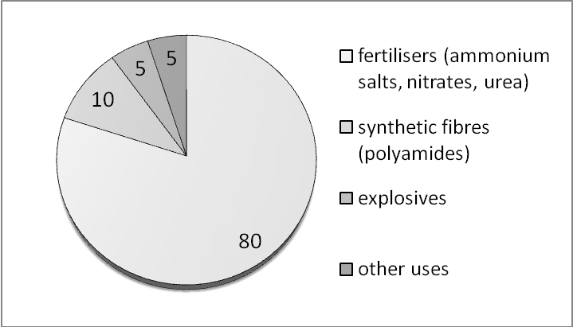

The ammonia synthesis here serves as an example of an **equilibrium reaction**, as well as for a large-scale industrial process.

**Problem 6:**

a) Write down the reaction equation for the ammonia synthesis. It is an equilibrium reaction, the forward reaction being exothermic.

b) How does the position of the equilibrium depend on the pressure and the temperature?

c) Thus, what reaction conditions (pressure and temperature) would you choose in order to obtain as much ammonia as possible?

d) An acceptable reaction rate is only reached with temperatures above 650 °C. However, with such a high temperature, the NH3 concentration is negligibly small. In what ways could the yield be increased?

The synthesis of ammonia was developed by two German chemists: Fritz Haber implemented it on a laboratory scale between 1903 and 1913, while Carl Bosch then established it in 1913 on a large-scale industrial level. Both received the Nobel Prize for their work. The ammonia synthesis is of great importance for the world nutrition, since it makes available nitrogen fertilizers in any amount. But it also had an effect on history: the nitric acid produced from ammonia made Germany independent of the import of nitrates from Chile (Chile saltpetre) for the production of explosives and ammunition - without the Haber-Bosch synthesis, World War I would certainly have been much shorter.

All the three methods mentioned in the answer to problem 6.d are used in practice.

The graph above shows the amount of ammonia in equilibrium depending on the reaction conditions of temperature and pressure. The syntheses is mostly carried out at about 450 °C and 300 bar. Grains consisting of highly pure iron blended with small amounts of different oxides (e.g. Al2O3, CaO, K2O) act as catalyst.

The biggest problems in the development of the ammonia synthesis were the development of a suitable catalyst as well as the pressure resistance of the reaction container at the required temperature.

Ammonia syntheses plant from BASF Ludwigshafen. Capacity: 1300 tons per day.

Ammonia synthesis plant from BASF Ludwigshafen. Capacity: 1300 tons per day (Copyright: Günter Baars).

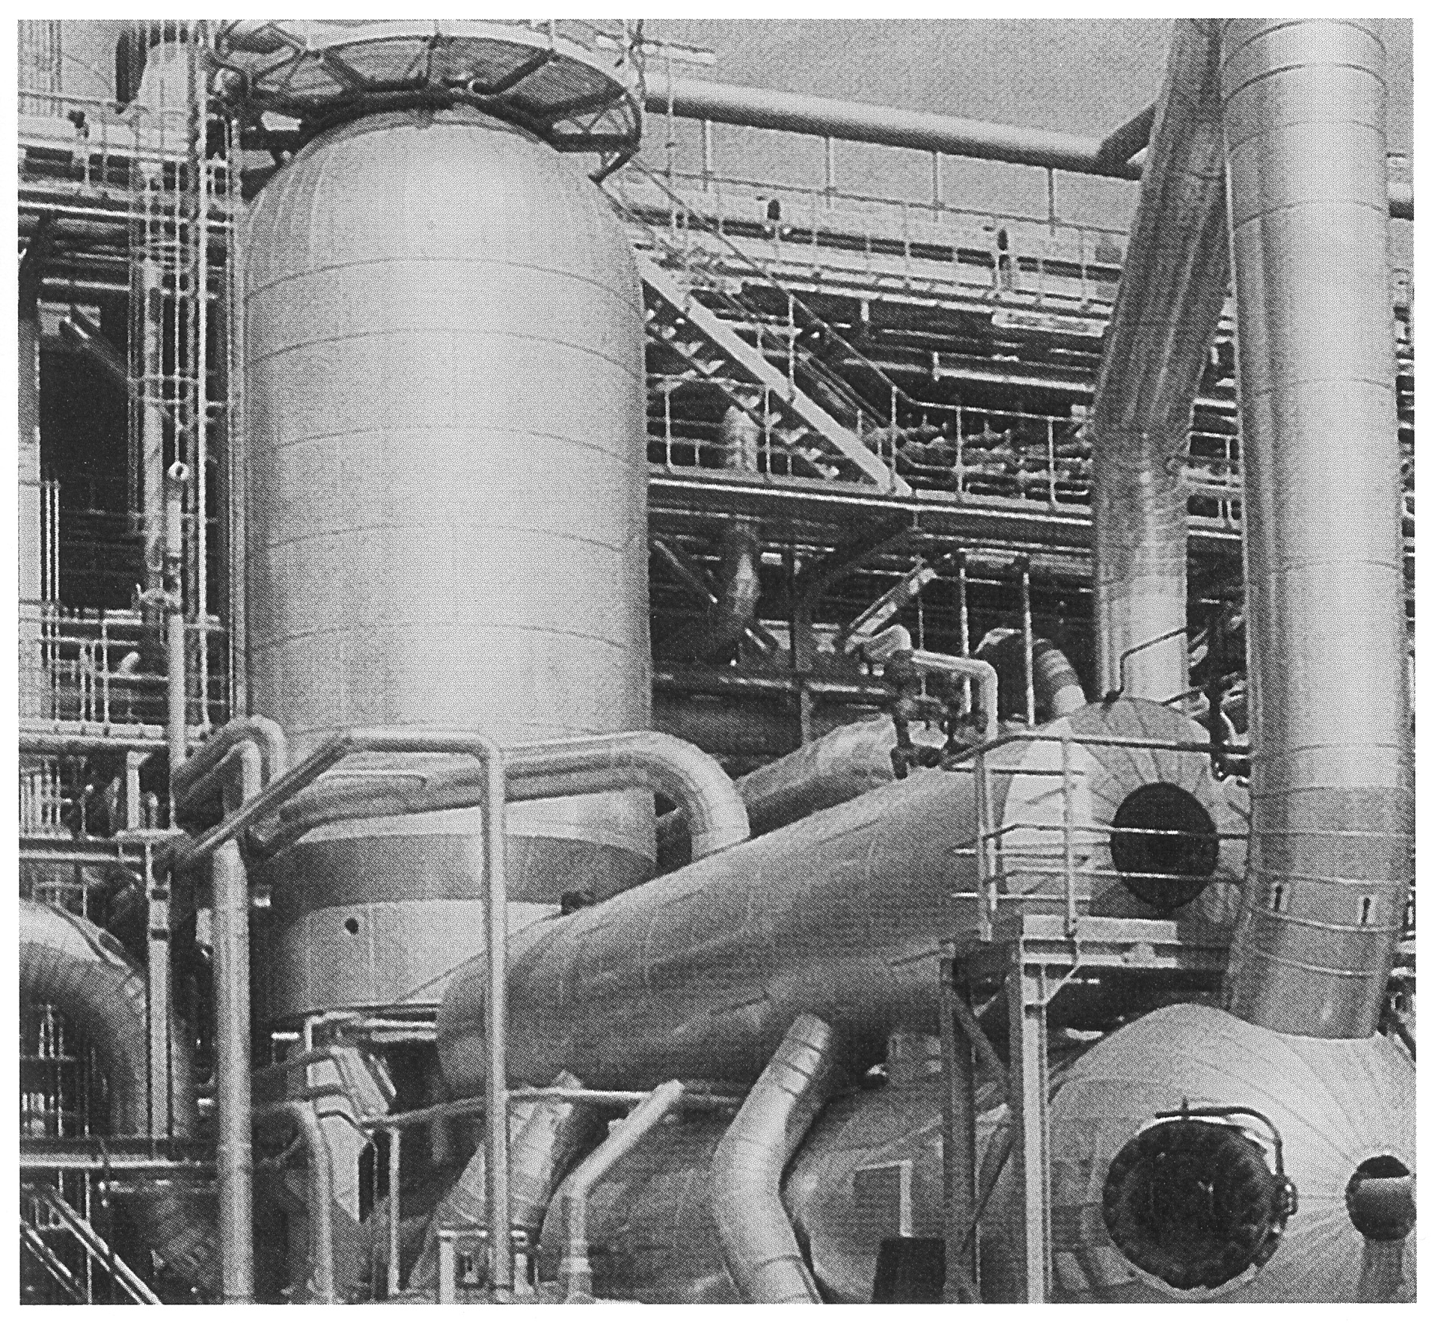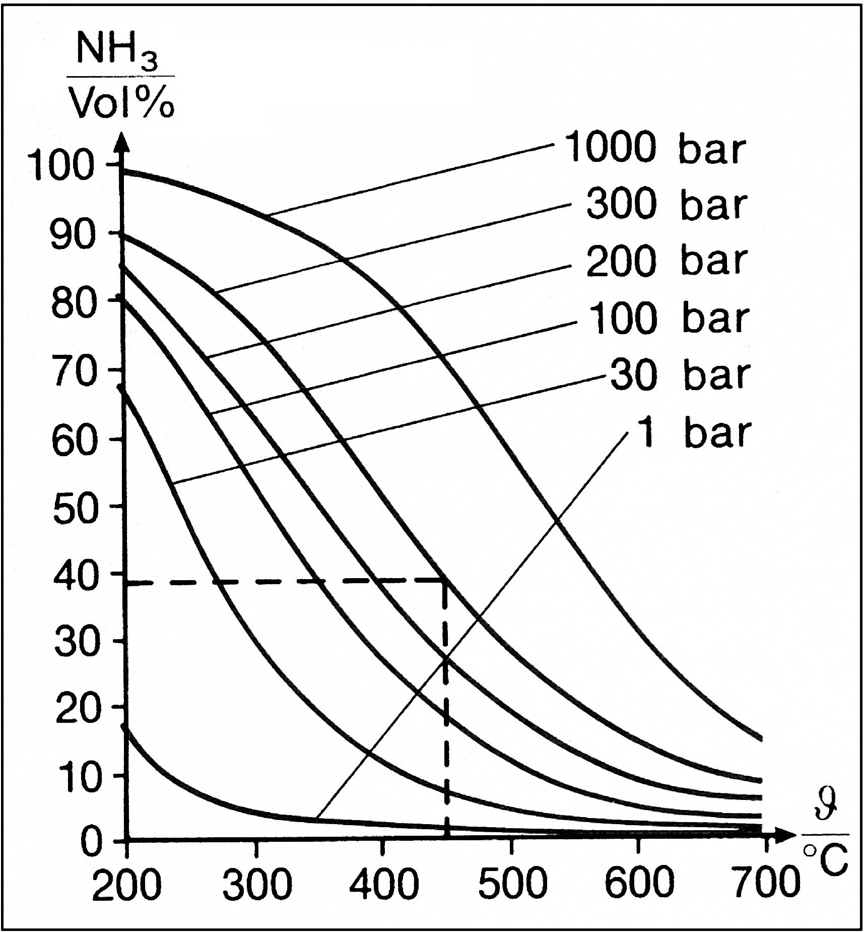

**Answers:**

**Problem 1:**

Iron(III) nitrate solution: Fe3+ = iron(III), NO3– = nitrate.

Potassium thiocyanate solution : K+ = potassium, SCN– = thiocyanate.

**Problem 2:**

a) K = 

b) The reactants combine forming product, until the equilibrium condition (the law of mass action) is again fulfilled: the equilibrium "shifts to the right".

c) As with problem b).

d) The product decomposes forming reactants, until the equilibrium condition (the law of mass action) is again fulfilled: the equilibrium "shifts to the left".

**Experiments:**

2) Fe3+: yellow, SCN–: colourless, Fe(SCN)3: dark red.

4) Yes.

5) See problem 2c.

6) Yes.

7) The Fe3+ concentration is lowered by the precipitation reaction → see answer of problem 2d.

8) Observation: The solution in the fifth test tube lightens more strongly through dilution than the sunset yellow solution.

Explanation: With the sunset yellow solution, only physical dilution takes place. In contrast, the iron(III) [thiocyanate](http://dict.leo.org/ende?lp=ende&p=thMx..&search=thiocyanate) complex breaks down with dilution, as can be shown with the law of mass action: all concentrations will become 4 times as small through dilution, so that the denominator is 64 times smaller than the numerator. The equilibrium is restored by a shift to the left - from the dark product to the light reactants.

9) With warming a shift to the left can be observed. This shows that the equilibrium constant decreases with increasing temperature.

**Problem 3:**

a) Shift to the left.

b) Shift to the left.

**Problem 4:**

a) There are twice as many molecules on the reactants’ side than on the products side. Therefore, with a pressure increase the equilibrium will shift to the right, with a pressure decrease to the left.

b) The release of pressure from removing the lid shifts the equilibrium to the right. Closing the lid causes the pressure to build up again, which stops the shift in equilibrium.

c) A shift to the left, since there are less gas particles on the reactant side.

**Problem 5:**

a) By heating to the left, by cooling to the right.

b) Less products, since the equilibrium shifts to the left.

c) It decreases.

d) Since the experiment in the sixth test tube showed, that with increasing temperature the equilibrium shifts to the left, the forward reaction must be exothermic.

**Problem 6:**

a) N2 + 3 H2 2 NH3



b) A pressure increase brings about a shift to the right, while a temperature increase leads to a shift to the left.

c) Ideally you would have the highest pressure possible and the lowest temperature (though the latter is not suitable due to kinetic reasons, cf. part d).

d) • With a catalyst, which increases the reaction rate so that the reaction proceeds quickly enough at lower temperatures.

• With high pressure, which shifts the equilibrium to the product side.

• By continuously removing ammonia from the reaction mixture, since product removal shifts the equilibrium to the right.

1. An example of a complex is an aquotised cation: in this case, the ligands are water molecules.
2. In German: "Gelborange S"
3. If that is not the case, dilute the darker solution with deionised water until both solutions are equally light, then discard the excess volume of the diluted solution, so that both solutions are equal in colour as well as in volume.
4. coke = outgassed coal, consists mainly of carbon.