The Great Climate Poker

Access “The Great Climate Poker” online (www.climatepoker.unibe.ch) and choose the “Mode for students”.

- Learn the basics

Question 1.1: Volcanic eruptions
Get familiar with the different climate factors described on the page “Playing poker with the climate”. What effect do volcanic eruptions have on climate? In the game, what is probability of getting a volcanic eruption?
Answer 1.1:
A volcanic eruption causes a cooling of Earth’s surface because the aerosols in the atmosphere reduce the solar irradiance. In the game, the probability of a volcanic eruption is 1/6 (one die has a 6), whereas the probability of no eruption is 5/6 (six dice have a 1). In reality, large volcanic eruptions are much less frequent. Because of the high impact of a strong volcanic eruption on global temperatures, an eruption is depicted by a 6.

Question 1.2: Solar activity
What causes variations in the sun’s intensity, as described in the game? If you click on the “Details” button you will see a more explicit description. What numbers on the die are possible for this climate factor?
Answer 1.2:
The sun’s activity is dependent on the turbulence of hot gases and changes in its magnetic field. The 11-year sunspot cycle changes the emitted energy of the sun by only approximately 0.1%. That’s why the probability of having slightly stronger or weaker solar output is 1/2: these dice all have 4’s and 3’s, respectively. Overall, the solar factor does not play such a large role (3’s and 4’s are quite similar).

Question 1.3: ENSO
Which die number corresponds to the strongest possible La Niña phase and how does the air circulate above the Tropical Pacific? What about the situation of a strong El Niño phase?
Answer 1.3:
The die with a 1 corresponds to the strongest La Niña, and 6 is the strongest El Niño phase. Every number in between 1 and 6 lies on the gradient between these two extremes. 3 and 4 describe a near neutral situation.
During a La Niña phase, the atmospheric circulation above the Tropical Pacific (Walker circulation) is dominated by rising air masses in the west and subsidence in the east. During an El Niño event, this circulation is broken up (see figures in “Details”).

Question 1.4: NAO
If the NAO is in its negative mode, what is the pattern of the Polar Jet? How does this affect climate over Europe? Which dice number responds to the most negative NAO phase?
Answer 1.4:
Click on the “Details” button to see a good diagram that answers this question. Basically, a negative NAO is accompanied by weak pressure systems and causes the Polar Jet to be diverted and flow around the North Atlantic in a wave-like pattern. This often causes cold and dry air masses to arrive over Europe from the northeast. The die with a 1 corresponds to the most strongly negative NAO anomaly.

- Limitations of describing climate as a poker game

Question 2: Assumptions of the game
Discuss the limitations and unrealistic assumptions made in the climate poker game. Create a list of points that are represented unrealistically in the game.
Answer 2:
- Probabilities fit to the dice
The occurrence of events in the game depends on the probability of the dice. In the game, a volcanic eruption occurs, on average, every 6 years. In reality, volcanic eruptions that are climatologically relevant occur much less frequently. You see this unrealistic assumption also in the “global” time series on the page “Climate poker” after rolling the dice: there are many low values due to volcanic eruptions which you don’t find in the real time series (i.e. the “real global”). Similar unrealistic assumptions to fit the dice’s numbers are made for the other climate factors.
- Temporal independence of the climate factors
The occurrence of the climate factors in the game is time independent; there is no autocorrelation in the time series. For example, each year that is rolled has the same probability of receiving a strong El Niño or La Niña. In reality, however, a mode may remain in the same state for several years (a typical ENSO cycles takes 3-7 years). It also takes typically 2-3 years until the atmosphere is cleared from aerosols after a large volcanic eruption.
- Missing other climate factors
There are other factors influencing the climate than the ones shown in this game. For instance, air pollution (i.e. aerosol emission) causes a reduction of global irradiance reaching the earth’s surface, leading to a cooling. This effect is known as global dimming. There are also a number of other circulation variability modes, such as the Pacific Decadal Oscillation (PDO), the Atlantic Multidecadal Oscillation (AMO), the Indian Ocean Dipole (IOD), etc.
- No interaction between the climate factors
In the game, the climate factors are independent. In the real world, these events may interact. A strong volcanic eruption in the tropics, for instance, affects the ratio of land and ocean temperatures, and thereby also affects the ENSO cycle.
- Linear increase of greenhouse gases
In the game, a linear increase of the greenhouse gas concentration over time is assumed and built into the game. This is the only time dependent die in the game! In reality, the increase of atmospheric greenhouse gases depends on various factors that are not accounted for in this game, such as global economics and population growth. The rate of greenhouse gas concentration in the atmosphere did not increase linearly in reality.
- Negligence of intra-annual effects
Many of the climate factors are most relevant for the climate during a certain period of the year (e.g. ENSO during austral summer). Because we only look at yearly anomalies, the sub-yearly effects are not reflected.

- Trend and variability

Question 3.1: Noticing trends
Go to the page “Climate poker” and roll the dice. After how many years do you begin to notice a trend for the global time series you have rolled? What about for the time series for Lima (Peru) and Bern (Switzerland)? What is the main difference between the global and the other time series?

Question 3.2: Greenhouse gases
What happens with the “Greenhouse gases”-die? What is the main difference between this die and all the others?
Answer 3.1 and 3.2:
The variability of anomalies is much higher on a local and regional scale (Lima and Bern). On large scales, regional and local variations equal out. If the variability is high, it is much more difficult to see a trend.
A trend can not be seen after just a few years because it is obscured by variability.
The thrown numbers of the dice are random and therefore show variability – except for the loaded “Greenhouse gases”-die. The numbers on this die are time dependent, and therefore only this die can cause a trend. The numbers of the die increase around every 20 years. Hence, the first 20 years are, per definition, only influenced by variability and not by a trend.

Question 3.3.a: R exercise: significance of trends
After how many years are the trends for Lima, Bern, and the global series (the time series after rolling the dice and the real time series) significant at the 0.05 level? Use the non-parametric Mann-Kendall Trend Test, which depends less on assumptions than, for example, the parametric Linear Regression Trend Test. However, one important assumption underlying the Mann-Kendall Trend Test is not satisfied by all time series: autocorrelations (i.e. when the next year is not independent from the previous year) should actually be removed before applying the trend test. In the rolled time series, there is per definition no autocorrelation. In the real time series, however, we most likely would detect autocorrelation due to the persistence of modes of the climate factors. For simplicity, we do not take into account autocorrelation.
Important: export the time series in .csv format from the page “Climate Poker” and save the file on your computer. Make sure to also activate all real time series (“real global”, “real Lima”, and “real Bern before exporting. You can activate or deactivate the time series by clicking on the legend of the graph (e.g., “real global”. We suggest using the statistical program R (www.r-project.org), but you may also use another software. Below is the R-code we suggest to help you solve this exercise:

# open the file containing the time series and name it "ts"
ts <- read.csv("your_directory/average-annual-temperature-anomalies.csv", sep=";")
# change the names of the time series to "global", "Bern", "Lima", "real global", "real Bern" and "real Lima"
colnames(ts) <- c("date","global","Bern","Lima","real global","real Bern","real Lima")
# check what the values look like
ts
# you need to install the package "Kendall" to perform the Mann-Kendall Test
install.packages("Kendall")
# activate the installed package
library("Kendall")
# test if the trends are significant (below the example for the first 100 years of the time series "global") and find the number of years, where the p-value drops below 0.05 (tau = measure of strength of the relationship between the time and the temperature anomalies, 2-sided = tests for positive as well as for negative trends, pvalue = measures the significance of the trend)
MannKendall(ts$global[1:100])

Answer 3.3.a:
The number of years after the p-value drops below 0.05 depends on the throws of the dice. For the time series “real global,” the real value drops below 0.05 after 27 years. Careful: after 10 years, the p-value drops under 0.05 for a few years already. If we look at the plot, we see that this supposed negative trend appears because of the series of cold years around 1910.
Question 3.3.b: R exercise: estimate the trends
In combination with the Mann-Kendall Trend Test, the Theil-Sen Trend Estimate is often used for trend estimation. Use R to estimate the trend of the time series. Afterwards, compare the “global” and “real global” trend estimates. How are they different, and what might explain this?
Below is the R-code we suggest to solve this exercise:

# open the file containing the time series and name it "ts"
ts <- read.csv("your_directory/average-annual-temperature-anomalies.csv", sep=";")
# change the names of the time series to "global", "Bern", "Lima", "real global", "real Bern" and "real Lima"
colnames(ts) <- c("date","global","Bern","Lima","real global","real Bern","real Lima")
# we need the "openair" package to calculate the Theil-Sen estimator (this is a large package and will take some minutes to download)
install.packages("openair")
# activate the installed package
library("openair")
# change the format of the years as required by the package
ts[,1] <- as.POSIXct(paste0(ts[,1],"-01-01 00:00:00"))
# calculate the Theil-Sen estimator and create a plot (seen below is the example for the "global" time series)
TheilSen(ts, pollutant = "global", dec.place=4, lab.cex=1.5, slope.text="°C/year", autocor=TRUE, date.breaks=10)

Answer 3.3.b:
The trend depends on the thrown dice. For the “real_global” time series (pictured below on the left), the estimated trend is 0.0072 °C per year (i.e. 0.72°C per century).
The rolled “global” trend is generally more linear (one example is pictured below on the right) – this results from the gradual increase of numbers of the “Greenhouse gases”-die. The global time series has several excursions, including the prominent temperature dip in the 1950s-70s. This is related to anthropogenic aerosol emissions (global dimming), which were later reduced thanks to air pollution control measures. This example demonstrates that “The Great Climate Poker” is an oversimplification of complex climatological processes.
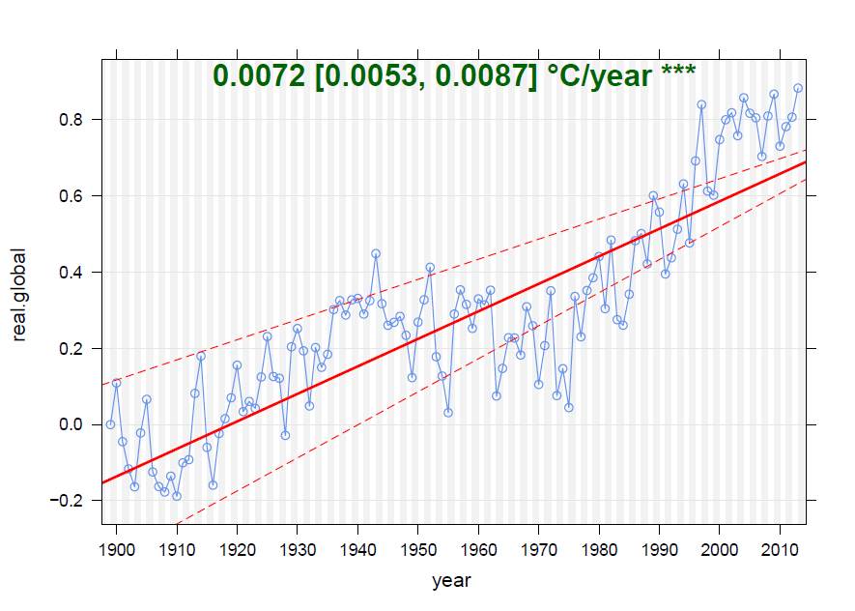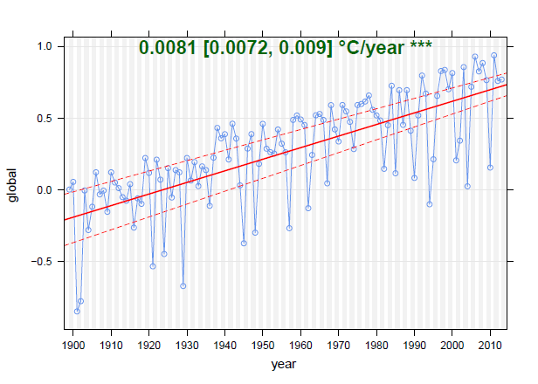

- Regional effect of climate factors

Question 4.1: Regional scale
Go to the page “Climate master”. Which climate factors are most important for which regions? What are the differences in the effects of the climate factors for Lima (Peru), Bern (Switzerland), and the global scale?
Answer 4.1
The climate factors do not affect temperature uniformly across the globe. Around the Tropical Pacific, ENSO is highly relevant, while in Europe and Bern, the NAO has a strong impact. Volcanic eruptions can especially reduce global temperature. The increase of greenhouse gases causes a high temperature increase, especially in high latitudes.

Question 4.2: Effects in Lima
Which climate factor is most dominant for climate in Lima? Can you verify your assumption with the real time series “real Lima” (go to the page “Climate poker”)?
Answer 4.2:
In the data “real Lima,” the absolute temperature peaks are found in 1983 and 1997. These two years were very strong El Niño years (see figure of the Niño 3.4 Index below: red marks El-Niño, and blue La Niña phases).

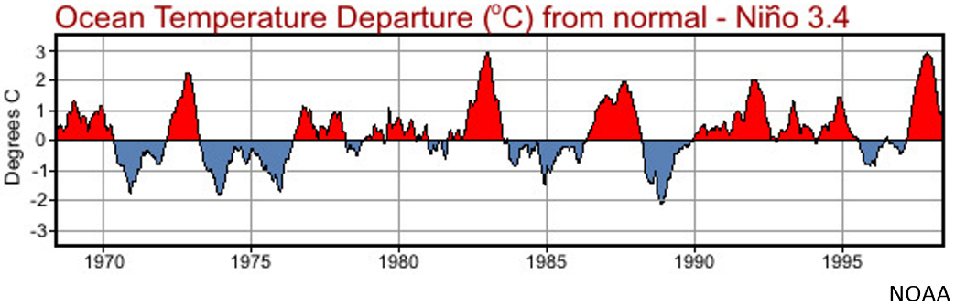

- Recognize anomaly patterns

Continue to the page “Climate detective”. Now you should be ready to attribute global anomalies to specific climate modes and events. Who is the best detective; who in the class is able to obtain the highest score in the “High Scores List”?

Instructions: you will be presented with five separate cases to solve – your high score is determined by the average of all five scores. You will solve cases one at a time. Once you make your guess by clicking on the combination of climate factors (i.e. the dice) and submit your solution by clicking on “Check your solution”, your answer is final and you can’t try to solve the same case again (but you will see the correct solution immediately afterwards!). To solve the next case click on “Roll” but not “Start over”, or you will lose your previous guesses. Good luck!

Answer 5:
The tutor may reward the winner of the game with a small price (e.g. some chocolate).

