Concentrations

Most chemical reactions take place in solutions. We therefore have no pure substances but certain amounts of them in a certain amount of a solvent. Thus, the important thing is the ratio of the substance to the solvent. Those ratios are called concentrations and we use four major ones, depending on the situation.

- Mass percent (w/w = “percent weight per weight”)

Unit [mass-%; m%; or often just %]
Definition Number of g of a substance in a mixture of 100 g.

Application The mass percent value describes the composition of a mixture of substances. The concentration of each component is expressed in percent of the total mass of the mixture.

Example A 5 m% sodium chloride solution consists of 5 g NaCl dissolved in water to give a total of 100 g.
In mass-%: 5 m% NaCl and 95 m% water.

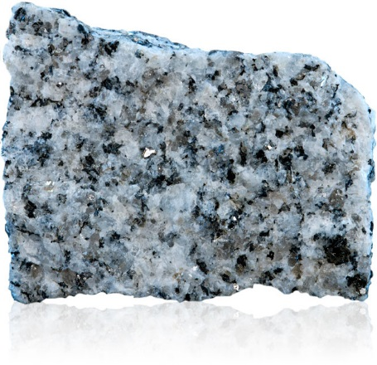
- A sample of granite with a total mass of 10.50 g contains three minerals:
5.30 g of quartz, 2.75 g of mica (Glimmer) and the rest is feldspar (Feldspat). Calculate the mass percent of each mineral in this piece of granite.

- Another sample of granite is composed of 65 % quartz. The sample has a total mass of 150 grams. Calculate the mass of quartz in the sample.

- A total of 60 g of sodium chloride (NaCl) are dissolved in 240 g water. Give the NaCl concentration in mass percent.

- What is the mass percent of each component in the mixture formed by adding 12 g of calcium sulphate (CaSO₄), 18 g of sodium nitrate (NaNO₃), and 25 g of potassium chloride (KCl) to 500 g of water?

- Brass is an alloy of 65 mass-% copper and the rest is zinc. A brass armlet contains 25 g of copper. How many g of zinc does it contain?

- Aluminium is the most abundant metal in the earth’s crust. However, it is never found as metal. Aluminium must therefore be extracted from aluminium compounds such as aluminium oxide (Al₂O₃). Aluminium oxide is 53 % aluminium by mass.

- How much aluminium oxide must be used to obtain 350 kilograms of pure aluminium?

- Aluminium oxide is found in a type of rock called bauxite. Bauxite contains approximately 55 % aluminium oxide. If 1500 kg of bauxite is used, what mass of pure aluminium can be gained?

- A mining company is extracting silver from an ore that is 0.014 m% silver. How many kilograms of ore must be processed in order to yield 0.70 kg of pure silver?

- Potassium chlorate (KClO₃) is a white, crystalline substance. When heated, oxygen gas is released and the salt potassium chloride (KCl) is formed.

- Give the equation of this reaction.

- A student heated 5.50 g of potassium chlorate in a test tube and found that the residue in the test tube had a mass of 3.35 g. What mass of oxygen was produced in the reaction?

- How many mass percent oxygen do the products contain? (Assume that the reaction goes to completion)

Extra tasks - mole percent

- To how many mole percent does this correspond?

- Give the mole percent of each component in the mixture described in question 4.
Molar masses: CaSO₄: 136.14 g/mol; NaNO₃: 84.99 g/ mol; KCl: 74.55 g/ mol; water: 18.02 g/ mol

- Volume percent (v/v = “percent volume per volume”)

Unit [Vol.-%]
Definition Number of mL of a dissolved substance in 100 mL of solution.
Application Ethanol content of beverages (liquid dissolved in a liquid).
Example 20 Vol.-% means that 20 mL of ethanol are dissolved in 100 mL of the beverage.

- What volume of alcohol do you consume if you drink one glass of the following drinks:

 | Shandy  (Beer + Sprite) | Beer | Red Wine | Kirsch
Vol.-% ethanol | 2.0 | 4.8 | 13.5 | 35
Ethanol concentration [mL/ 100 mL]
Volume of the beverage [mL] | 300 mL | 300 mL | 100 mL | 40 mL
Total volume of ethanol in the beverage [mL]

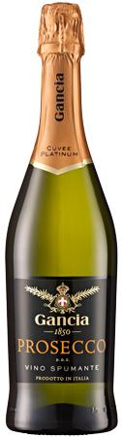
- Which volume of Malibu Liquor (21 vol.-%) contains the same amount of ethanol as one glass (100ml) of Prosecco (10.5 vol.-%)?

- A large bottle of whisky (40 vol.-%) has a volume of 1l. How many 3dl bottles of beer contain the same amount of ethanol as one large bottle of whisky?

- Severe acute ethanol intoxication (= drinking far too much!) can lead to unconsciousness and eventually to death. The deadly blood ethanol concentration is 0.4 to 0.5 Vol.-% (4 to 5 per mille). How many mL of ethanol are dissolved in the blood of a person with a blood ethanol concentration of 0.5 Vol.-%? (Total blood volume in the body: 5L)

3. Mass concentration (w/v = “weight per volume”)

Unit [g/L]
Definition Number of g of a dissolved substance in one litre of solution.

Application Contents of liquids, e.g. beverages (solid dissolved in a liquid).
Example A 5 g/L sodium chloride solution consists of 5 g NaCl dissolved in water to give a total volume of 1000 mL. Therefore, the volume includes the solvent as well as the dissolved substance!
The above solution is often called a 5% sodium chloride solution. However, it is recommended to avoid this notation, as it could be confused with m% or Vol.-%.

- The following table was found on a bottle of balsamic vinegar. Calculate the concentrations in [g/L].
100 mL contain
Proteins | 500 mg
Carbohydrates | 24 g
Fat | 100 mg

- Transform the following concentrations into [g/L]. (Hint: 1L = 1 dm3; 1 mL = 1 cm3)

a) 100 mg/dL b) 20 mg/dm3 c) 5 mg * cm-3

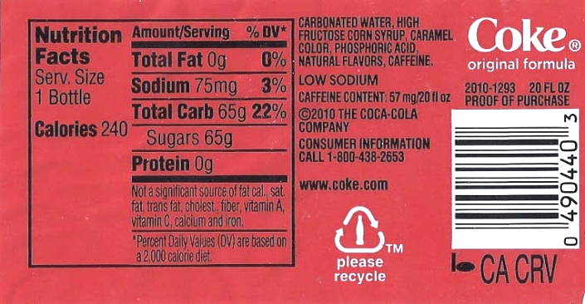
3. The following information is given on the nutrition facts label of a 6dl Coke bottle. “Sugars” refers to sucrose (C₁₂H₂₂O₁₁).

- Give the sucrose concentration in [g/L].

- How many sugar cubes are dissolved in a half-litre bottle of Coke? One sugar cube weighs 4 g.

- How much sugar do you have to eat in order to get your daily “calories”? The recommended values for women and men are about 2,100 (=8,800 kJ) and 2,400 calories (=10,000 kJ) respectively (see label!).

- Extra task: How many moles of sucrose are dissolved in a 1.5 litre bottle? (Do you remember the definitions of the mole and the molar mass?)

4. Molarity

Unit [mol/L] = [M]
Definition Number of moles of a dissolved substance in one litre of solution. Thus the volume includes the solvent and the dissolved substance! If nothing else is mentioned the solvent is always water.

Application In chemistry the number of particles that are dissolved in a solution matters more than the weight. Chemists need to know how many dissolved particles are available for chemical reactions (see problems 9 to 12). Thus, mol/L is the unit of choice in chemistry.

Example Sucrose (table sugar) has a molar mass of 342.34 g/ mol. If 342.34 g of sucrose are dissolved in water to yield a total of one litre of solution, the concentration is 1 mol/L = 1M.

1. How many grams of sodium hydroxide (NaOH) need to be dissolved in one litre of water in order to get a NaOH solution with a molarity of 1 mol/L (= 1 M).

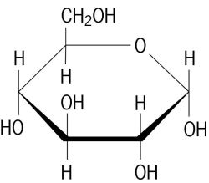
2. Glucose (grape sugar) is a white powder that is water-soluble.
It has the molecular formula C₆H₁₂O₆ (see picture on the right).

- How many moles of glucose are dissolved in 1 litre of a glucose solution that has the concentration 18.02 g/L? What is the molarity [M] of this solution?

- How do you make 1 litre of a 2 M glucose solution in the lab?

- What if you only need 250 mL of the 2 M glucose solution?

3. A 200 mL solution contains 1.42 g sodium sulphate (Na₂SO₄). Calculate the molarity of this solution.

4. How many litres of a 0.88 M solution can be made with 25.5 g of the salt lithium fluoride (LiF)?

5. How many mL of a sodium hydroxide solution with a concentration of 0.5 mol/L are needed to make 250 mL of a 0.1 M solution?

6. A total of 35 mL of a 0.75 M Al₂(SO₄)₃ solution are mixed with 100 mL of a 0.15 M Al₂(SO₄)₃ solution. Calculate the molarity of the resulting solution.

7. A total of 100 mL of a 0.5 M sucrose solution are mixed with 250 mL of sucrose solution of an unknown concentration. The molarity of the mixture is 1.56 M. Calculate the molarity of the unknown concentration.

8. In producing remedies for diseases, homeopaths use a process called "dynamisation" or "potentisation", whereby a substance is diluted (e.g. 1:100 or even 1:50,000) with alcohol or distilled water and then vigorously shaken by ten hard strikes against an elastic body. This is typically repeated about 30 times. Calculate how many molecules of the original substance can be expected in the final solution (for 1:100).

9. How many mL of KOH_{(aq)} 0.25 M (=potassium hydroxide solution) react with 15 mL of a 0.35 M sulphuric acid (H₂SO₄) solution according to the following equation: 2 KOH + H₂SO₄ K₂SO₄ + 2 H₂O

10. Oxalic acid (H₂C₂O₄) reacts with NaOH: H₂C₂O₄ + 2 NaOH Na₂C₂O₄ + 2 H₂O
A total of 25 mL of oxalic acid react with 37.5 mL of 0.22 M NaOH_{(aq)}. Determine the concentration of the oxalic acid.

11. Phosphoric acid (H₃PO₄) is added to 125 mL of a barium chloride (BaCl₂) solution. As a result, 3.26 g of solid Ba₃(PO₄)₂ are formed.

- Formulate the chemical equation.

- Calculate the molarity of the BaCl₂ solution.

12. When a certain amount of sodium (Na) is added to water, 50.4 mL H₂ gas (at 20°C and 1013 hPa) and 175 mL of NaOH solution are formed.

- Formulate the chemical equation.

- Calculate the molarity of the NaOH solution.

Lorenz Marti, Karin Schläpfer, 2015

