Chemistry Lab Course
Exercises

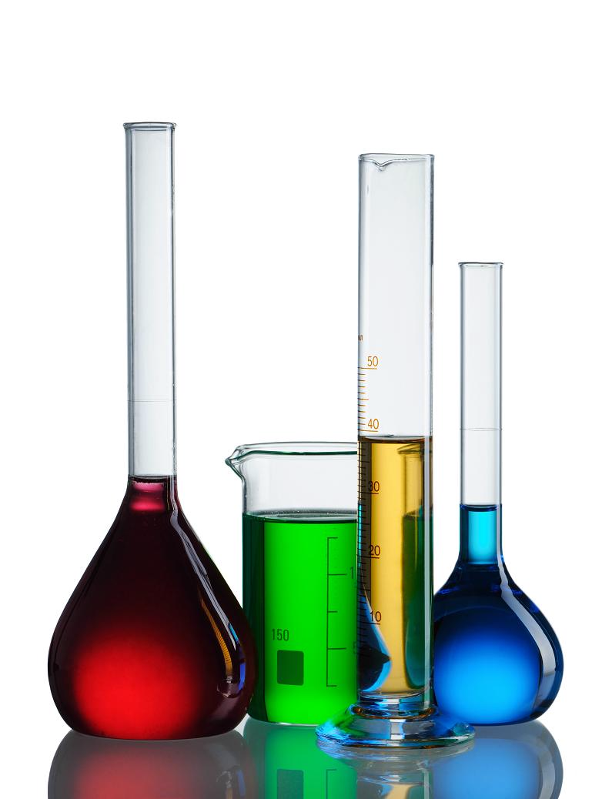
Kantonsschule Zürich Nord
Tilmann Geldbach

Practising Basic Lab Operations
Lab Work Sheet
Weight of sodium chloride
Concentration of NaCl solution

Extinction of stock solution

Reaction Rates
Lab Work Sheet

Exercise 1 (4 Credits)
Draw a graph showing the concentration-dependence of the reaction rate. The x-axis should be the concentration, the y-axis the reaction rate. Chose a reasonable scale for your graph!

 | A | B | C | D | E | F
Concentration S₂O₃²⁻ [^{mol}/_{L}]
Time until turbid [s]
Reaction rate [^{1000 ES}/_{s}]

Exercise 2 (2 Credits)
How could you describe the dependence between the concentration of thiosulphate and the reaction rate? Which is the order for the rate law with respect to the thiosulphate concentration?
Exercise 3 (4 Credits)
Lab Work Sheet
Draw a graph showing the temperature-dependence of the reaction rate. The x-axis should be the temperature, the y-axis the reaction rate. Chose a reasonable scale for your graph!
 | R | S | T | U | V
Concentration S₂O₃²⁻ [^{mol}/_{L}]
Temperature [°C]
Time [s]
Reaction rate [^{1000 ES}/_{s}]

Exercise 4 (2 Credits)
Are your observations in agreement with the Q₁₀ temperature coefficient (RGT-Regel)? Comment on your results and try to explain possible deviations from this rule of thumb.

Exercise 5 (2 Credits)
Could you think of other ways to influence the reaction rate of this reaction? Make possible suggestions.

Distillation of a Binary Mixture
Lab Work Sheet

Exercise 1 (2 Credits)
Complete the following table with your observations
Fraction | elapsed time when starting the collection of the fraction | temperature at the still head at the beginning of the collection of the fraction | Content of substance A
 |  |  | in mL | in %
1
2
3
4
5
6
7
8
9

Exercise 2 (2 Credits)
Draw a chart showing the composition of the different fractions using the graph below. Briefly comment on your results: Are these as expected or is there some data that doesn't make sense? Which is a likely source of error in this experiment?
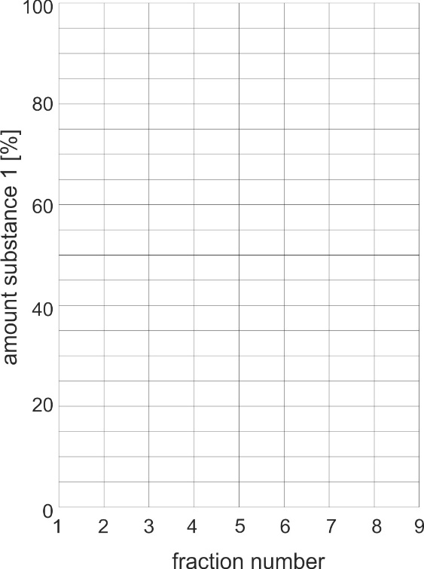

Exercise 3 (2 Credits)
Lab Work Sheet
Print the temperature diagram obtained from Excel and paste it onto this worksheet (or draw a reproduction)
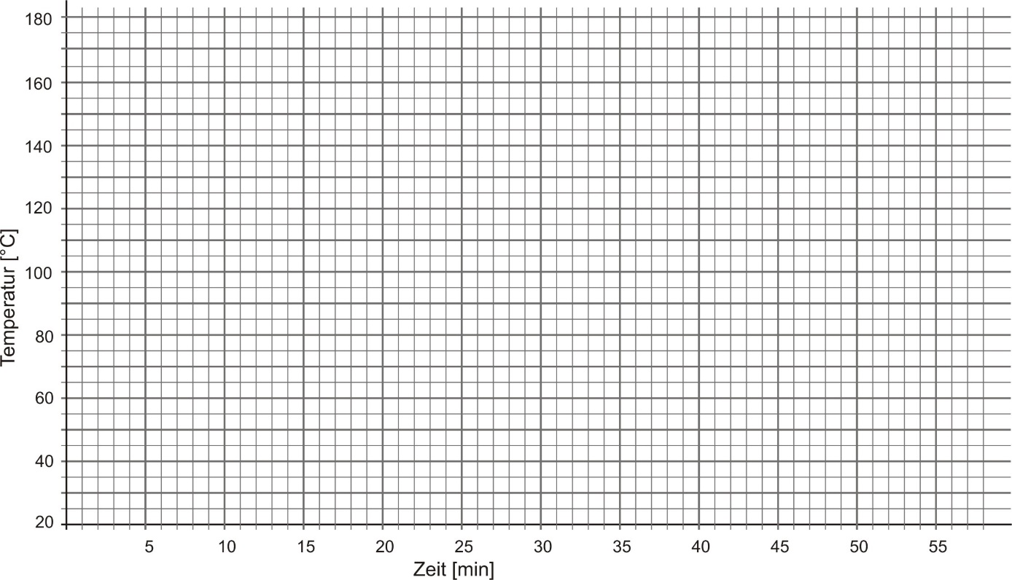

Exercise 4 (2 Credits)
Determine the boiling points of substances A and B with the help of the recorded temperature curves
Boiling point substance A | ______ °C | Boiling point substance B | ______ °C

Exercise 5 (3 Credits)
Try to explain why the two temperature curves at the still head and in the distillation flask are so different:
- Why is there a sharp increase in temperature at the still head but not in the distillation flask?
- Why does the temperature in the distillation flask rise gradually and only in the end catches up with that measured at the still head?

Recrystallisation as a Means of Purification
Lab Work Sheet

Exercise 1 (2 Credits)
State the complete reaction equation for dissolving potassium permanganate in water

Exercise 2 (1 Credits)
Draw the complete molecular structure (Lewis formula) of the ClO₄⁻ anion

Exercise 3 (2 Credits)
Draw a microscopic representation of a hydrated potassium ion – water molecules should be drawn as complete Lewis formula.

Exercise 4 (3 Credits)
On which factors does the solubility of a salt in water depend on (which energetic processes need to be considered)? Which conclusions can be drawn from the composition formula of a salt with respect to its solubility?
Exercise 5 (4 Credits)
Lab Work Sheet
Analyse the graph on the solubility of potassium perchlorate and potassium permanganate: Which amount [%] of KClO₄ remain in the filtrate if:
a) 100 mL of a saturated KClO₄ solution are cooled from 100 °C to 20 °C
b) 100 mL of a saturated KClO₄ solution are cooled from 60 °C to 20 °C
What is the consequence of the result of your calculation regarding how this experiment ought to be carried out? Under which conditions is the method of recrystallisation most efficient?

Observations and Notes

Chromatography of Essential Oils
Lab Work Sheet

Exercise 1
Paste the copies of your chromatograms into the boxes below

Exercise 2 (2 Credits)
Complete the following table
 | Petrol ether / ethyl acetate 5:1 | petrol ether / ethyl acetate 3:1
Thymol | R_{f} = | R_{f} =
Menthol | R_{f} = | R_{f} =
Eucalyptol | R_{f} = | R_{f} =

Exercise 3 (3 Credits)
- Which essential oils contain large amounts of eucalyptol?........................................................................................

- Which essential oils do not contain any thymol? ......................................................................................................

- Which essential oils contain large amounts of menthol? ….....…...............................................................................
Exercise 4 (3 Credits)
Lab Work Sheet
Analyse the two chromatograms shown below and mark those spots which belong to the same substance. Which experimental conditions need to be fulfilled such that different chromatograms may be compared with each other?
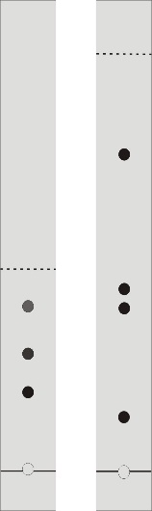

Exercise 5 (3 Credits)
Based on your results from the different experiments, complete the following statements:

- The more polar a substance the ............................................................ its Rf-value.

- The higher the ratio of ethyl acetate in the mobile phase the ............................................................ the Rf-value.

- The more substance is applied the ............................................................ the Rf-value.

Observations and Notes

HCl-Fountain
Lab Work Sheet

Exercise 1 (1 Credit)

Write down the complete reaction equation for the reaction between NaCl and H₂SO₄.

Exercise 2 (1 Credit)
What is the difference between hydrogen chloride and hydrochloric acid?

Exercise 3 (2 Credits)
Why is it possible to trigger the reaction between HCl and water by rinsing the round-bottom flask with acetone? If you don't have any idea then pour a small quantity of acetone on the back of your hand – what can you notice?

Exercise 4 (2 Credits)
Why is it important that the tube from the dropping funnel is connected to the long glass tube of the round-bottom flask (see representation in the instruction)?
Observations and Notes
Lab Work Sheet

Cosmetics
Lab Work Sheet

Exercise 1 (2 Credits)
State two examples for emulsifiers which are used for cooking. What are they used for (which ingredients are emulsified)?

Exercise 2 (2 Credits)
Draw a representation of a drop of oil which is dispersed in an aqueous phase by means of an emulsifier

Exercise 3 (1 Credit)
For the preparation of the cooling gel ethanol is added to hot water … why is it important that the water is not boiling at the time of the addition?

Exercise 4 (2 Credits)
How is the cooling sensation of the gel achieved?

Exercise 5 (2 Credits)
Lab Work Sheet
Which factors are decisive for the quality of an emulsion? How can these be influenced during formulation?

Exercise 6 (2 Credits)
An emulsifier which is well soluble in a fat is typical for a water-in-oil emulsion. Which kind of emulsion is the hand crème? Explain your assumption.

Exercise 7 (2 Credits)
Why are the aqueous phase and the fatty phase mixed at elevated temperatures rather than at ambient temperature?

Observations and Notes

Determination of the Hardness of Wat er
Lab Work Sheet

Total Hardness (2 Credits)
 | Sample 1 | Sample 2
Volume EDTA solution
Amount of Ca²⁺ + Mg²⁺ [mol]
Concentration Ca²⁺ + Mg²⁺ [^{mol}/_{L}]
Degree of Hardness [°fH]

Calcium Hardness (2 Credits)
 | Sample 1 | Sample 2
Volume EDTA solution
Amount of Ca²⁺ [mol]
Concentration Ca²⁺ [^{mol}/_{L}]
Degree of Hardness [°fH]

Carbonate Hardness (2 Credits)
 | Sample 1 | Sample 2
Volume hydrochloric acid
Carbonate hardness [°KH]

Exercise 1 (2 Credits)
What happens when hard water is boiled? State a complete reaction equation and make some comments.

Exercise 2 (2 Credits)
What is the difference between temporary and permanent hardness?
Exercise 3 (2 Credits)
Lab Work Sheet
You want to wash your hair with soft water – should you use cold or hot tap water? Why?

Exercise 4 (2 Credits)
Why does it depend on the hardness of water how much washing powder needs to be used for cleaning your clothes?

Exercise 5 (2 Credits)
Why is the tap water in the city of Zurich rather soft whereas the tap water in for example Kloten is much harder?

Observations and Notes

Limestone, Carbonic Acid and Lime Plaster
Lab Work Sheet

Heating a solution of sodium hydrogen carbonate (3 Credits)
Observations:

Reaction equation and interpretation:

Heating a sample of “hard” water (containing lime) (3 Credits)
Observations:

Reaction equation and interpretation:

Setting of lime plaster (3 Credits)
Observations:

Reaction equation and interpretation:

Exercise 1 (2 Credits)
Lab Work Sheet
Make a graphic with the corresponding reaction equations representing the lime cycle

Observations and Notes

