**Ground level ozone  
(Self-Study Module)**

From the environmental point of view, ozone in the atmosphere is of importance in two respects: on the one hand, ozone in high altitudes functions as a protective shield against ultraviolet radiation; on the other hand, ground level ozone is the most important air pollutant in many developed countries, including Switzerland. This self-study module deals with this second function of ozone. It provides you with basic knowledge needed to understand the causes of air pollution and possible counteractive measures. Furthermore, the process of ozone formation is a typical example of a complex dynamic equilibrium (steady state), which is frequently encountered in environmental chemistry.

**1.) What is ozone?**

Ozone is a modification of oxygen with the formula O3. The ozone molecule is mesomeric[1]; it is described by the following two contributing structures:



Ozone is a very reactive gas and one of the strongest oxidants. Among its uses are the bleaching of paper and the sterilisation of water; in these reactions it is broken down to O2. Ozone often originates from electrical discharges (sparks, lightning) or from the effect of short wave UV-light on O2. Ozone has a typical odour which is still noticeable at concentrations as small as 50 µg/m3. It is a strong poison, which has a maximum workplace concentration value (= "MAK-Wert"[2]) of 200 µg/m3.

**2.) Ozone in the stratosphere and troposphere**

The atmosphere can be split up into different layers (see the following diagram), of which the two lowest, the troposphere and the stratosphere, are the most important for ozone chemistry. 90% of all the ozone in the atmosphere is found within the stratosphere, the rest is within the troposphere. However, we are dealing with very small amounts: if the total ozone in the atmosphere could be taken out, it would lead - under normal temperature and pressure conditions - to a layer only 3 mm thick!

In the stratosphere, ozone is produced through the effect of short wave UV-light on O2 molecules. Stratospheric ozone (the "ozone layer") protects creatures on the earth's surface from harmful UV-rays. Chlorofluorocarbons catalyse ozone depletion and in doing so, shift the equilibrium of formation and depletion towards lower ozone concentrations (the "ozone hole"). This then leads to higher UV-exposure on the earth.

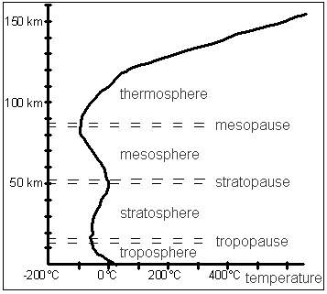

As a result of its toxicity, ozone in the troposphere is a harmful substance. The formation of tropospheric ("ground level") ozone is our subject here; stratospheric ozone (the "ozone hole") will not be discussed further.

The temperature in the troposphere decreases with increasing height, whereas it increases in the stratosphere because of the absorption of UV-rays. Between both layers, a thin layer with no temperature gradient is found and is called the tropopause. It represents a barrier, which severely restricts the mixing between the troposphere and the stratosphere. Therefore, there is normally hardly any connection between the ozone layer and the ground level ozone. Occasionally however, the tropopause can be momentarily and locally breached, so that cold and ozone rich air in the troposphere sinks; this is called a stratospheric injection.

**3.) Overview of ground level ozone: formation and effects**

Ozone is a so-called secondary pollutant, i.e. a pollutant which itself is not emitted, but arises through chemical conversions from other substances in the environment.

**Problem 1:** Use the internet to answer the following questions:

a) From which precursor pollutantsdoes ozone form? From which sources do these come from?

b) Which weather conditions enhance ozone formation?

c) What is summer smog?

d) What are the effects of high ozone concentrations on health and environment?

Air pollutants have considerable impact, but their concentrations are small - usually less than 100 µg/m3.

**Problem 2:** In Switzerland, the average ground level NO2 concentration in densely populated areas is between 25 and 50 µg/m3. – One in how many molecules in the air is a NO2 molecule? Assume an NO2 concentration of 40 µg/m3 and a molar volume[3] of 24 l/mol.

Nitrogen oxides acting as ozone precursors are the two gases nitrogen monoxide (NO) and nitrogen dioxide (NO2), which together often are referred to as NOx. NO is produced by combustion reactions, mainly by those which do not run continuously in a constant flame, but as repeated explosions; this is why petrol and diesel engines are the main emission sources of nitrogen oxides.

**Problem 3:** Even though petrol and diesel contain virtually no nitrogen compounds, their combustion in engines produces nitrogen monoxide.

a) Where does the nitrogen for the NO formation come from?

b) How does NO form? Specify the reaction equation.

The reaction in part (b) is endothermic. It takes place at high temperatures, caused e.g. by flames or sparks. However, at room temperature virtually no NO is formed since the equilibrium of the NO formation lies strongly to the reactants’ side.

c) Which rule can be used to explain that the equilibrium lies much more to the left side at room temperature than at combustion temperature?

d) If the equilibrium lies so heavily to the side of the reactants at surrounding temperature - why does the air still contain NO?

e) The burners used in modern oil heating are designed to operate at comparatively low flame temperatures. Why?

NO reacts with atmospheric oxygen producing nitrogen dioxide according to the equation 2 NO + O2 → 2 NO2. This reaction proceeds much slower than the conversion from NO to NO2 caused by volatile organic compounds (VOC), which will be described in the next section by equations [8] to [12].

**4.) Formation and depletion of ozone in the troposphere**

The most important source of ozone in the troposphere is the reaction of NO2 with O2. It takes place in two steps. The first consists in the fission of NO2 by short wave light (λ ≤ 410 nm[4]), whereby atomic oxygen forms:

[1] NO2 ⎯light→ NO + O

Oxygen atoms are very reactive and immediately form ozone when in contact with oxygen molecules, so the second step is:

[2] O + O2 → O3

Combining reactions [1] and [2] results in

[3] NO2 + O2 ⎯light→ NO + O3

But ozone can also be broken down, primarily through the reaction

[4] NO + O3 → NO2 + O2

for which no light is required.

Reactions [3] and [4] running simultaneously result in an equilibrium with constant concentrations:

[5] NO2 + O2 NO + O3

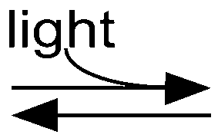

**Problem 4:**

a) To which side does the equilibrium [5] shift when the light intensity increases? To which side does it shift when the light intensity decreases?

b) What happens when an additional reaction takes place, which uses up NO and produces NO2, but which - in contrast to reaction [4] - doesn't consume any O3? Note that such a reaction constantly removes NO from the equilibrium [5], and is supplying NO2 to it at the same time.

There is a reaction with the characteristics mentioned in Problem 5.b. It occurs when hydrocarbons or molecules with hydrocarbon residues are present in the air. Such substances - mainly vapours of solvents and fuels - are referred to as volatile organic compounds (VOC).

The above-mentioned reaction comprises several steps and will consequently be described with equations [8] to [12]. It is catalysed by hydroxyl radicals[5] (•OH), which are produced by a reaction of ozone with water vapour according to equations [6] and [7]. Reaction [6] uses UV-light (λ  ≤ 310 nm); an excited (energy-rich) O-atom (O*) results:

[6] O3 ⎯Licht→ O* + O2

[7] O* + H2O → 2 •OH

The reaction of a VOC molecule R-CH3 with a hydroxyl radical again results in a radical:

[8] R-CH3 + •OH → R-CH2• + H2O

Radicals are also involved in the following reactions:

[9] R-CH2• + O2 → R-CH2-O-O•

[10] R-CH2-O-O• + NO → R-CH2-O• + NO2

[11] R-CH2-O• + O2 → R-CHO + •O-O-H

[12] •O-O-H + NO → •OH + NO2

In each of the reactions [10] and [12], one NO molecule is converted into a NO2 molecule. Reaction [11] produces a so-called aldehyde[6]. Aldehydes irritate the respiratory system; they are - like ozone - a component of summer smog.

**Problem 5:**

a) Combine equations [8] to [12] to produce an equation for the overall reaction.

b) Explain why the hydroxyl radical isn’t a reactant but a catalyst.

**Problem 6:** Study the following diagram.

a) Label the reactions with the numbers used in the above text.

b) How many ozone molecules result from the reaction of one VOC molecule (RCH3)?



When the boundary conditions like light intensity, air movement, emissions etc. do not change, a state is reached after some time in which reactions [8] to [12] proceed at a constant rate. The particles involved in the cycle (•OH, R-CH2•, R-CH2-O-O•, R-CH2-O•, •O-O-H) remain in constant concentrations, since the rates of their formation and decay are equal. Such a state is called a steady state[7].

If all the reactions of such a system are known, as well as the data characterising them (equilibrium constants, rate laws[8]) and the boundary conditions, the steady state concentrations can be calculated. But in the real world, a part of this information is always missing, and many factors (e.g meteorological ones) can not be calculated because of their complexity. Therefore, the results of such model calculations are always afflicted with uncertainty.

In reality, the system displayed above is not closed. The participating substances are taking part in further numerous reactions, which have been left out here for sake of simplicity and straightforwardness, like for example:

• Formation of the so-called photooxidants (components of summer smog, which have similar effects to ozone).

• Reaction of NO2 with •OH, producing HNO3 (nitric acid), which in contrast to NO2 is quite soluble in water and is therefore washed out of the atmosphere by the rain.

• Removal of ozone by so-called deposition, i.e. by reaction with the earth's surface (including plants).

• The influence of carbon monoxide (CO): in the presence of nitrogen oxides, it has a an effect similar to that of the VOC, forming ozone under the influence of sunlight. However, in areas where the nitrogen oxide concentrations are very slight, the carbon monoxide enhances ozone depletion.

Thus, man-made air pollution interferes with a rather complex dynamic equilibrium of atmospherical processes.

In order to minimise ground level ozone formation, the emission of its precursors (VOC and NOx) has to be reduced. The nitrogen oxides should anyway be reduced, since they are noxious to health and environment: they are harmful to the respiratory tract, and they form nitric acid, which damages plants and buildings and produces salts actring as fertilisers in nutrient-poor ecosystems, thereby reducing biodiversity.

**Problem 7:** In the following graph, the result of an experiment is shown. Explain the shape of the three curves.

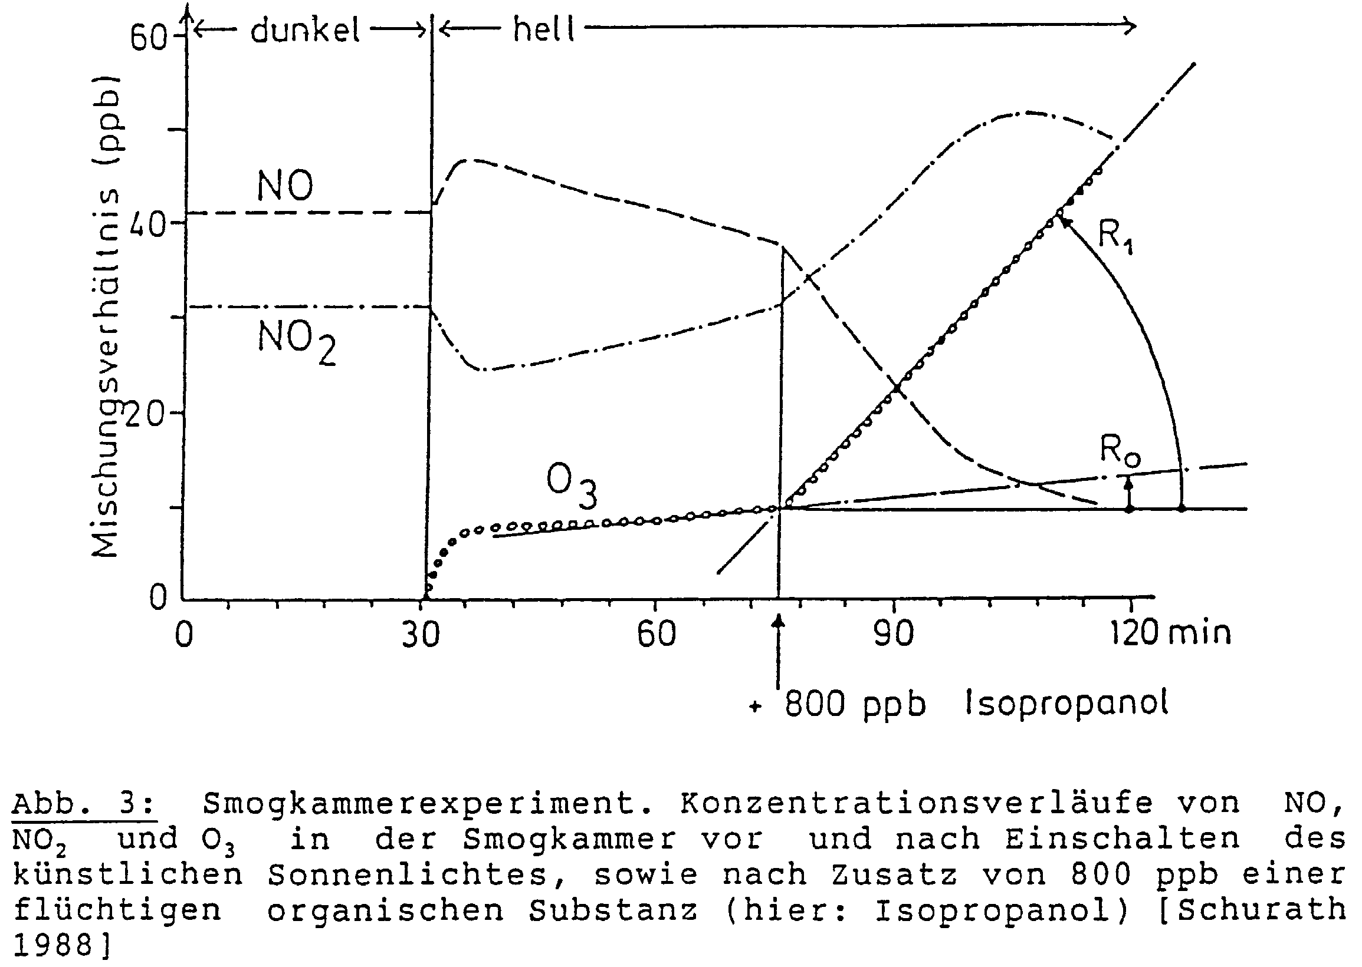

**5.) Temporal and spatial variations of ozone concentrations**

**Time of day:**

The adjacent graph shows the typical daily fluctuations in the concentrations of NO2, NO and O3 on a sunny day in a city centre.

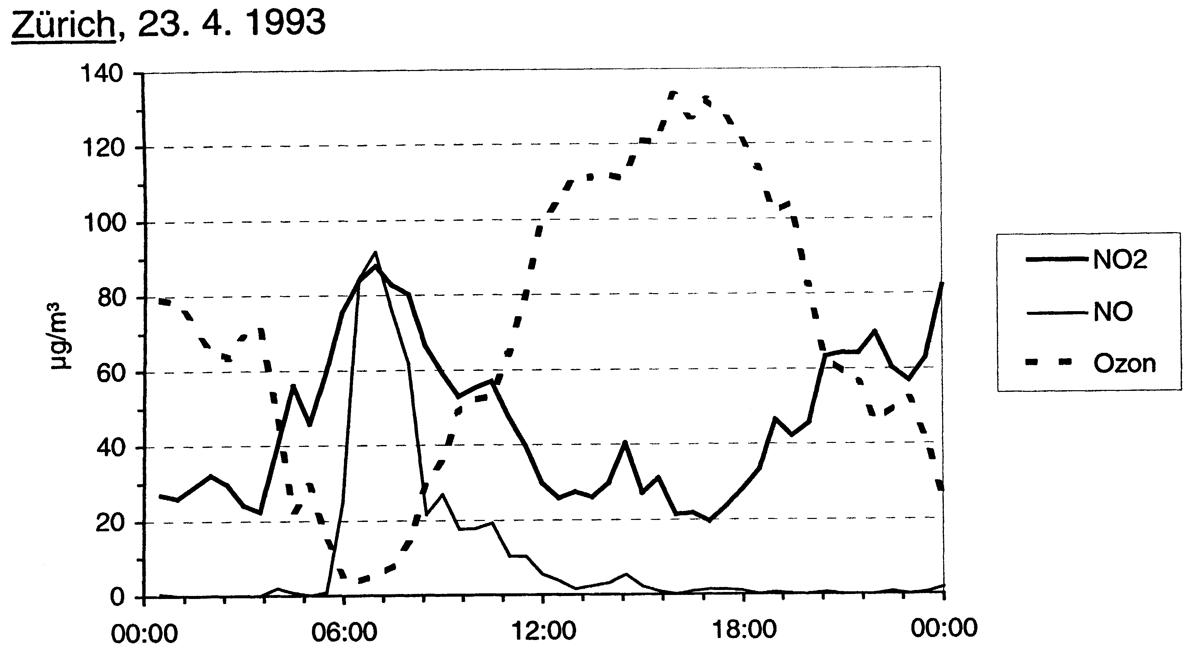

With the exhaust gases from the morning traffic, NO is emitted, which reacts with the leftover ozone from the previous day to give NO2. Therefore, the NO2 concentration rises, while that of the O3 falls. Only when almost no more O3 is available to transform the NO which is still being emitted, does the NO concentration rise. - Then, under the influence of the increasing insolation, ozone is formed through the day, whose concentration rises sharply. The NO2 which thereby is transformed into NO is constantly regenerated by the VOC. - At the same time, the concentration of the nitrogen oxides originating from the morning traffic falls gradually because of thinning by dispersal. Towards evening, ozone production subsides as a result of the decreasing sunshine intensity.

**Problem 8:** In contrast to the morning traffic, why does the evening traffic not lead to an increase of the NO concentration?

**City and countryside:**

The following graph compares the daily fluctuations in ozone concentration in a city centre with the one in a rural area:

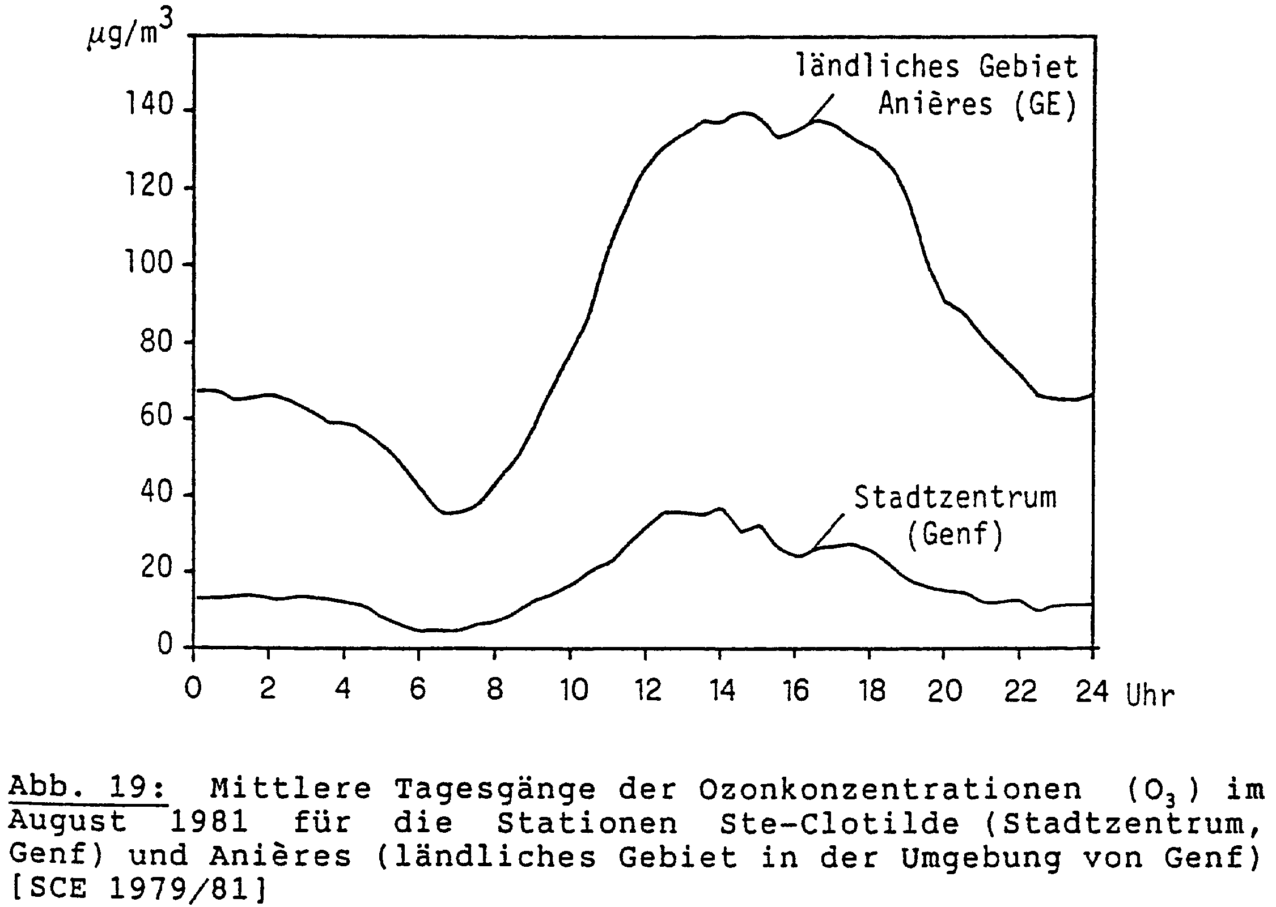

In rural areas the change of pollutant concentrations during the day is usually less pronounced than in the cities, since less primary pollutants are emitted. In particular, the ozone concentration doesn’t fall as much in the evening due to the reduced emission of NO. However, ozone which moves during the day from the city to the countryside can stay there overnight and accumulate for several days. Therefore, the ozone concentration is often higher in rural areas than in the cities.

The graph dates from a time when cars weren’t equipped with catalytic converters. Nowadays there is less difference between city and country, since there is less ozone depleting NO in the cities too.

**Season and weather:**

**Problem 9:**

a) Why are the critical values of ozone only exceeded in summer?

b) Explain the variations in the concentrations of ozone and nitrogen dioxide in the following graph, considering the weather data on the next page.

**Legend of the curves:**

• top: ozone (continuous: Zürich city; dotted: Bachtel)

• middle: NO2

• bottom: SO2

**Critical values:**

O3: 120 μg/m3; SO2: 100 μg/m3; NO2: 80 μg/m3.

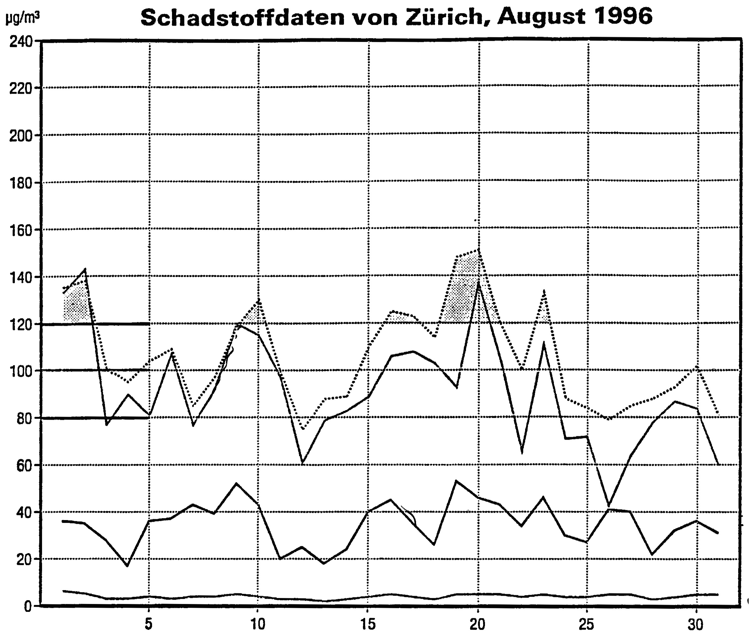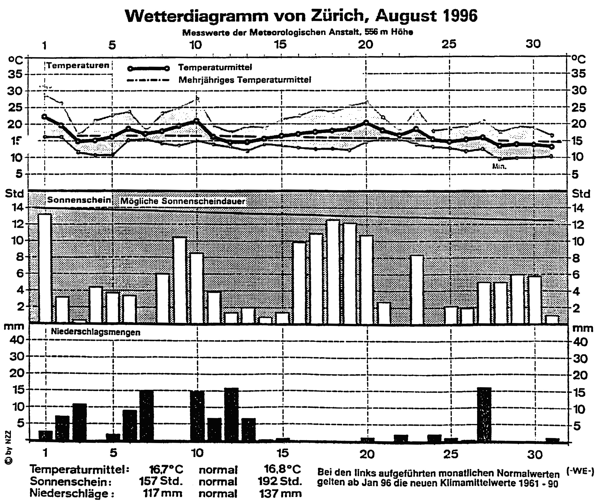

**Data interpretation:**

**Problem 10:**

a) Go to the internet site of the Swiss Federal Office for the Environment (Bundesamt für Umwelt, BAFU) *www.bafu.admin.ch* and click on *English* in the upper right corner of the page. Select *Air* among the topics, then *Air pollution > NABEL[9] monitoring network*. On the right of the page, select the publication "NABEL. National Air Pollution Monitoring Network" and download it. The NABEL network comprises 16 monitoring stations, representing different typical locations. Name the location types - you‘ll find them on pages 7 to 9 of the report.

b) Choose a nearby monitoring station. Go back to *Air pollution*, select *Data query NABEL →* *Query by station*. Ask for graphic represention of the hourly means[10] of ozone, temperature and global radiation for your station for a period of 2 to 3 weeks in summer. Can you explain the dependency of the ozone concentration on the weather data?

c) Ask for graphic representation of the hourly means of ozone and NO2 for a period of 2 to 3 days only. Do the curves correspond to what you have learned about the daily fluctuations in the concentrations?

d) Select *Query by pollutant → Ozone (O3)*. Choose some monitoring stations which represent different location types and a period of about one week in summer and ask for the daily values. Explain the differences between the locations.

e) Search the internet for the Swiss immission limit values of ozone.

f) Go back to *Air pollution* on the BAFU site, select *Historical data > Graphics of annual data*. On how many days per year does the hourly average level of ozone exceed the immission limit value of 120 µg/m3? During how many hours per year is this the case? Check this for last year as well as for 2003 with its extraordinary hot summer.

g) Besides NABEL there are also regional (inter-cantonal) air measuring networks in Switzerland. For German-speaking Switzerland, measured data can be found on the following internet sites:  
• *www.in-luft.ch* for central Switzerland and Aargau  
• *www.ostluft.ch* for eastern Switzerland  
• *www.luft-bs-so.ch* for the cantons Solothurn and Basel

Inform yourself about the air quality in your region.

**Answers:**

**Problem 1:**

a) Ozone arises from nitrogen oxides (NOx) and volatile organic compounds (VOC). Nitrogen oxides are formed in combustion processes; they are emitted mainly by motor vehicles, but also by industries. The volatile organic compounds comprise solvent vapours, as well as vapours and combustion residues of petrol; they come from the traffic and the industries in almost equal parts.

b) Ozone's favoured conditions are warm weather with strong solar radiation.

c) Summer smog is polluted air forming in periods of intense sunshine in summer. Besides ozone, it contains some other secondary pollutants like formaldehyde, peroxyacetyl nitrate and nitric acid.

d) Impact on human health: Irritation of the eyes and the respiratory tract; diminished respiratory capacity and physical fitness, respiratory diseases.

Impact on the vegetation: Damage to tree leaves in the forest, crop losses in agriculture.

**Problem 2:**

Molecules in 1 m3 (= 1000 l) of air: 1000 l / 24 l/mol = 41.67 mol

Molecules in 40 µg (= 40∙10-6 g) of NO2: 40∙10-6 g / 46 g/mol = 8.69∙10-7 mol

Only 1 in 41.67 / 8.69∙10-7 = 4.79∙107 ≈ 48 million molecules is a NO2 molecule.

To illustrate this figure: if people were atmospheric molecules, there would be only one NO2-person in the whole of Spain!

**Problem 3:**

a) The nitrogen source is the elemental nitrogen (N2) contained in the air.

b) The integral parts of air, nitrogen and oxygen, react according to the equation  
N2 + O2 → 2 NO.

c) According to Le Châtelier’s principle, a rise in temperature moves the equilibrium to the side with the energy rich substances, i.e. the products of the endothermic reaction; lowering the temperature moves it to the other side.

d) The combustion waste gases cool down quite quickly after leaving the exhaust tube. At the low surrounding temperature, the reaction is very slow, so that the new equilibrium doesn't establish itself.

e) This design has the advantage of low NO emissions.

**Problem 4:**

a) By increasing the light intensity, the equilibrium [5] moves to the right, while decreasing it moves it to the left.

b) As long as this reaction is running, ozone is produced.

**Problem 5:**

a) R-CH3 + 2 O2 + 2 NO → H2O + 2 NO2 + R-CHO

b) The hydroxyl radical isn’t used up, since in reaction [12] as much •OH is produced as is used in reaction [1].

**Problem 6:**

a) See the following figure:



b) Two, since the reaction of one VOC molecule converts two NO into NO2 molecules, each of them producing one ozone molecule by reaction [3].

**Problem 7:**

The concentration changes in the first few minutes after the switching on of the light are being caused by reaction [3]; because of the formed ozone, then reaction [4] comes into play. - Still before an equilibrium between NO, NO2 and O3 has been set up, a volatile organic compound is added. Thereby, the cycle of reactions [8] to [12] begins, and through reactions [1] and [2] large ozone production takes place. Since reactions [10] and [12] are faster than reaction [1], a high NO2- and a low NO- concentration results. See the diagram in Problem 6.

**Problem 8:**

At the time of the evening traffic, much ozone is available; thus the emitted NO is immediately converted into NO2 (ozone depletion according to equation [4], which proceeds relatively quickly because of the high O3 concentrations). As a consequence, the concentration of NO2 rises while that of O3 falls.

**Problem 9:**

a) Mainly because reaction [1] depends on solar radiation, but also because all reactions run faster at higher temperature.

b) The ozone concentration follows more or less the concentration of the precursor NO2. It is lower in the city than in the countryside (Bachtel). It correlates with the sunshine duration, with a delay of one or two days.

**Problem 10:**

a) urban, near a main road

urban, in a park

suburban

rural, near a motorway

rural, below 1000 m altitude

rural, above 1000 m altitude

High-altitude

b) High global radiation (i.e. strong insolation) should result in high ozone values.

c) See chapter 5, section "Time of day".

d) See chapter 5, section "City and countryside". The main factor are the NO emissions resulting from road traffic. In the south (Ticino), besides climatic factors the immissions from the Milan region play a role too.

e) The one-hour-average level of 120 µg/m3 may be exceeded only once per year.

98 % of the half-hour-average levels of a month must not exceed 100 µg/m3.

You can find these values for example on the BAFU site under *Air > Legislation and enforcement > Regulatory framework* → *4. Ordinances* → [*Ambient air quality standards as established in the LRV*](http://www.bafu.admin.ch/luft/00632/00634/index.html?lang=en&download=NHzLpZeg7t,lnp6I0NTU042l2Z6ln1ad1IZn4Z2qZpnO2Yuq2Z6gpJCDeIB_fmym162epYbg2c_JjKbNoKSn6A--)

f) Select *Ozone: annual mean* and check the tables "number of hourly mean values > 120 µg/m3" and "number of days with maximum hourly mean value > 120 µg/m3".

1. Mesomeric molecules contain bonding electrons which are delocalised over several atoms. Therefore, they cannot be described by a single structural formula, but rather as an intermediate of two or more so-called contributing structures. For the ozone molecule, the two contributing structures tell us that the two bonds are equivalent (each of them neither a single nor a double bond but something in between), and that the O-atoms on both ends carry the same charge.
2. MAK is the abbreviation for “maximale Arbeitsplatzkonzentration”, the legal limit for air pollutants at workplaces.
3. According to Avogadro’s theorem, the molar volume is the same for all ideal gases, regardless of their chemical constitution. Like all gas volumes it depends on temperature; it is 24 l/mol at 19.5 °C.
4. λ denotes the wavelength of light. The wavelength of visible light covers the range of 400 to 700 nm; ultraviolet (UV) light has shorter, infrared longer wavelengths.
5. Radicals are particles containing unpaired electrons in their outer shell. The unpaired electron is symbolised by a dot in the formula. Radicals are very reactive particles.
6. Aldehydes are organic substances with the general formula  (abbreviated: R-CHO)
7. in German "Fliessgleichgewicht"
8. A rate law mathematically describes the reaction rate as a function of the reactants‘ concentrations.
9. NABEL stands for "**Na**tionales **Be**obachtungsnetz für **L**uftschadstoffe"
10. in German "Stundenmittelwerte"