**Synthesis of Aspirin (acetylsalicylic acid)**

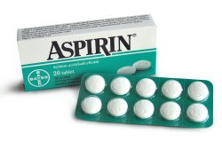Aspirin, also known as acetylsalicylic acid, is the world’s best-selling drug. It is used to relieve minor pains (analgesic), to reduce fever (antipyretic) and as an anti-inflammatory medication. Aspirin also has an antiplatelet effect by inhibiting the production of thromboxane, which under normal circumstances binds platelet molecules together to create a patch over damaged walls of blood vessels. At low doses, it is used to help prevent heart attacks, strokes, and blood clot formation in people at high risk of developing blood clots.

[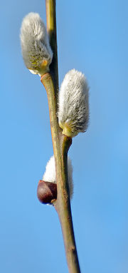](http://de.wikipedia.org/wiki/Bild:Willow_catkin_1_aka.jpg)

For the synthesis of Aspirin, we use the base material from which it was produced originally, when first produced in 1853: salicylic acid. However, while salicylic acid used to be extracted from willow bark, it is now produced chemically.

*Fig.: Male catkins of a willow (Salix alba)*

**Chemical equation of the synthesis**

salicylic acid + acetic anhydride 🡪 Aspirin + acetic acid

C7H6O3 + C4H6O3 🡪 C9H8O4 + C2H4O2





**Safety** Acetic anhydride and concentrated sulphuric acid are strongly corrosive; you must therefore work under a **fume hood**. Wear safety goggles at all times.

**Equipment** heater, water bath pan, glass rod, beakers, Erlenmeyer flasks

**Chemicals** salicylic acid, acetic anhydride, concentrated sulphuric acid (catalyst).

**Procedure** Fill the water bath pan half-full with hot water and set the heater on maximum. Reduce the temperature once it reaches 60°C.Place 12.2 g of salicylic acid in a 250 ml Erlenmeyer flask, add 15 ml of acetic anhydride and 6 drops of concentrated sulphuric acid. Attach the flask in the hot water bath using a socket and a cramp. Heat the mixture for 10 minutes, swirling occasionally.

Remove the flask from the hot water bath and let it cool for one minute. Slowly add 150 ml of ice-cold water. Filter off the raw aspirin using vacuum filtration.

**Purification**  The raw aspirin is not yet pure enough. Therefore, it has to be recrystallised.   
  
On the heater, place a 250 ml beaker containing 35 ml of ethanol next to a 100ml Erlenmeyer flask containing 80 ml of water. Heat both to 70°C.  
The raw aspirin is to be completely dissolved in the ethanol, and then the hot water is added. Put this beaker into a bigger one, which contains 2 cm of water as well as a small amount of crushed ice. Do not move or stir.  
  
After 20-30 minutes, when all the aspirin has crystallised, the product is filtered off by vacuum filtration.

**Analysis** Calculate the maximum yield.