**Synthesis of esters: natural and artificial flavourings**

|  |  |
| --- | --- |
|  | ***Safety Precautions:***  Concentrated sulphuric acid can cause extreme burns if spilled on skin or in eyes.  Alcohols and carbonic acids are somewhat flammable and they should be kept away from flames.  **🡺 *Wear safety goggles throughout!*** |

When an organic acid (R-COOH) and an alcohol (R-OH) are mixed together and heated in the presence of an acid catalyst (such as H2SO4), the two will react to form an ester (plus H2O). This process is called esterification.

Each ester has its own unique odour, and with a discriminating nose, one can use this fact to help identify them.

**Background**

Esters, derivatives of carboxylic acids, are found in a variety of natural sources. Simple esters generally have pleasant odours, and are the main components of many of the odours and flavours of fruits and flowers. Most odours and flavours are the result of a complex mixture, with one ester predominating. Because esters are easy to synthesize, flavour chemists often use esters, either one or several, to reproduce or enhance natural flavours.

Although esters are often used as flavourings, they are rarely used as scents to be applied on the body. This is because esters are not highly stable, and can be hydrolysed back to carboxylic acids and alcohols when exposed to perspiration. Since esterification is a reversible reaction, the addition of acid, water and heat (perspiration) favours hydrolysis. And, unfortunately, many simple carboxylic acids have a very unpleasant odour.

Some esters are also bioactive. Isoamyl acetate, which smells like bananas, is also an alarm pheromone released by honey bees when they sting an intruder. The pheromone attracts other bees and incites them to attack the intruder.

The general reaction scheme for the ester formation is shown below:

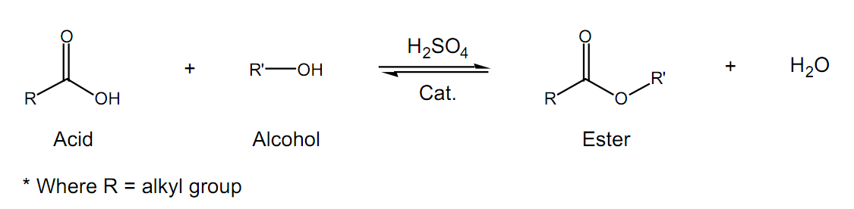

It is important to note that this is a reversible reaction, so the acid and alcohol reactants and ester products are in equilibrium (implied by the double arrow). What this means is that once the reaction reaches equilibrium, there could be a large amount of starting material remaining, resulting in a poor yield of the ester. In order to resolve this problem we make use of Le Chatelier's principle, which predicts that we can drive the equilibrium to the right (to the products) by having one of the reactants in excess. Either the alcohol or the acid can be used in excess. The choice can be based on cost, availability and/or ease of purification at the end of the reaction. In this reaction we will add an excess of the acid.

Sulphuric acid (H2SO4) is used as a catalyst for this reaction in order to accelerate the rate at which the product is formed. Since a catalyst is not consumed during the course of a reaction, you need to use only a small amount of sulphuric acid in order for it to be effective. Heating is another way to increase the reaction rate. We will heat the reaction using a reflux apparatus. Refluxing is a process where liquid (your reaction mixture) is heated to its boiling point, with a condenser attached, so that some of the liquid vaporizes, rises part-way up the condenser, and then condenses and falls back down into the reaction flask. This process allows the reaction to be heated over a period of time, without evaporating away the solvent or reactants.

**Equipment:** magnetic stirrer/hot plate, water bath, round bottom flask 100ml, reflux condenser, 2-3 boiling chips, volumetric pipette (10 ml), dropping pipette, separating funnel (250 ml)

**Chemicals:** glacial (concentrated) acetic acid (=ethanoic acid), concentrated sulphuric acid, various carbonic acids and alcohols, ice

**Choose one of the following combinations:**

a.) 5 ml glacial acetic acid and 7.5 ml ethanol: ethyl acetate (glue)

b.) 2.0 g salicylic acid and 10 ml methanol: wintergreen oil  
(For this reaction do not add any ice after the synthesis!)

c.) 5 ml glacial acetic acid and 7.5 ml 1-pentanol: pear

d.) 1.0 g benzoic acid and 7.5 ml Ethanol: cloves

e.) 1.0 g benzoic acid and 7.5 ml 1-pentanol

f.) 5 ml propionic acid and 7.5 ml 1-butanol (warning: propionic acid reeks of billy goat!)

Basically, every combination with a carbonic acid and an alcohol is possible. We use always 0.1 mol of the carbonic acid and 0.15 mol of the alcohol. The reason we use more alcohol than acid is that this allows us to shift the equilibrium more to the products.

**Procedure:**

Set up the apparatus in the fume hood. Measure the exact amount of alcohol and carbonic acid and transfer them to a 100ml round bottom flask using a funnel. Add 10 drops of concentrated (!) sulphuric acid and 2-3 boiling chips. Swirl to mix.

Fill some hot water into the water bath and place it on the hot plate. Carefully lower the round bottom flask into the water bath using cramps and sockets. Put on the reflux condenser and attach the rubber tubes for the cooling water. The reaction mixture now has to reflux for 10 minutes.

Then pour your product into 50 ml of ice cooled water in a 250ml beaker and stir. Transfer the liquid part (without ice) to a separating funnel. A layer of ester will separate and float on top of the aqueous layer. Smell the product by gently wafting the odour towards your nose with your hand – do not put your nose near the top of the tube!

**Evaluation:** Compare the odours of the different esters prepared by other groups. Write down the equation for your reaction using structural formulae.

**Disposal:** The aqueous parts can be disposed down the drain with lots of water. All esters should be placed in the organic waste container provided.