Auschwitz

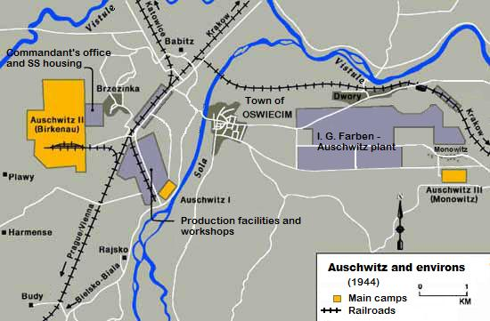
Auschwitz was the largest camp established by the Germans. It was a complex of camps, including a concentration, extermination, and forced-labour camp. It was located near Cracow (Krakow), Poland. Three large camps constituted the Auschwitz camp complex: Auschwitz I, Auschwitz II (Birkenau), and Auschwitz III (Monowitz). More than one million people lost their lives at Auschwitz, nine out of ten of them Jewish. The four largest gas chambers could each hold 2,000 people at one time.
Victims who were spared immediate death by being selected for labour were systematically stripped of their individual identities. They had their hair shaved off and a registration number tattooed on their left forearm. Men were forced to wear ragged, striped pants and jackets, and women wore work dresses. Both were issued ill-fitting work shoes, sometimes clogs. They had no change of clothing and slept in the same clothes they worked in.
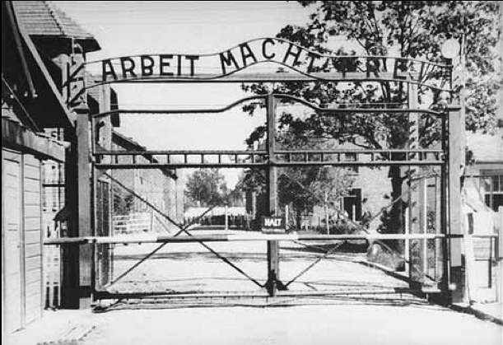
A sign over the entrance to the camp read “Arbeit macht frei”. In actuality, the opposite was true. Labour became another form of genocide that the Nazis called "extermination through work." Each day was a struggle for survival under unbearable conditions. Prisoners were housed in primitive barracks that had no windows and were not insulated from the heat or cold. There was no bathroom, only a bucket. Each barrack held about 36 wooden bunk beds, and inmates were squeezed in five or six across on the wooden plank. As many as 500 inmates lodged in a single barrack. Food consisted of watery soup made with rotten vegetables and meat, a few ounces of bread, a bit of margarine, tea, or a bitter drink resembling coffee. Diarrhea was common. People weakened by dehydration and hunger fell easy victim to the contagious diseases that spread through the camp.
Some inmates worked as forced labourers inside the camp, in the kitchen or as barbers, for example. Women often sorted the piles of shoes, clothes, and other prisoner belongings, which would be shipped back to Germany for use there. The storage warehouses at Auschwitz-Birkenau, located near two of the crematoria, were called "Canada," because the Poles regarded that country as a place of great riches. At Auschwitz, as at hundreds of other camps in the Reich and occupied Europe where the Germans used forced labourers, prisoners were also employed outside the camps, in coalmines and rock quarries, and on construction projects, digging tunnels and canals. Under armed guard, they shovelled snow off roads and cleared rubble from roads and towns hit during air raids. A large number of forced labourers eventually were used in factories that produced weapons and other goods that supported the German war effort. Many private companies, such as I. G. Farben and Bavarian Motor Works (BMW), which produced automobile and airplane engines, eagerly sought the use of prisoners as a source of cheap labour.
Escape from Auschwitz was almost impossible. Electrically charged barbed-wire fences surrounded both the concentration camp and the killing centre. Guards, equipped with machine guns and automatic rifles, stood in the many watchtowers. The lives of the prisoners were completely controlled by their guards, who on a whim could inflict cruel punishment on them. Prisoners were also mistreated by fellow inmates who were chosen to supervise the others in return for special favours by the guards.
Cruel "medical experiments" were conducted at Auschwitz. Men, women, and children were used as subjects. SS physician Dr. Josef Mengele carried out painful and traumatic experiments on dwarfs and twins, including young children. The aim of some experiments was to find better medical treatments for German soldiers and airmen. Other experiments were aimed at improving methods of sterilizing people the Nazis considered inferior. Many people died during the experiments. Others were killed after the "research" was completed and their organs removed for further study.
Most prisoners at Auschwitz survived only a few weeks or months. Those who were too ill or too weak to work were condemned to death in the gas chambers. Some committed suicide by throwing themselves against the electric wires. Others resembled walking corpses, broken in body and spirit. Yet other inmates were determined to stay alive.

Text: http://www.ushmm.org/outreach/en/article.php?ModuleId=10007718 (adapted); images: http://www.jewishvirtuallibrary.org/jsource/Holocaust/auent.html; http://upload.wikimedia.org/wikipedia/commons/6/6c/Map_of_Auschwitz_and_environs%2C_1944.jpg

