Nazi Propaganda: Film

1) Film programme for Der Ewige Jude (1940)
The film begins with an impressive expedition through the Jewish ghettoes in Poland. We are shown Jewish living quarters, which in our view cannot be called houses. In these dirty rooms lives and prays a race, which earns its living not by work but by haggling and swindling. From the little urchin to the old man, they stand in the streets, trading and bargaining. Using trick photography, we are shown how the Jewish racial mixture in Asia Minor developed and flooded the entire world. We see a parallel to this in the itinerant routes of rats, which are the parasites and bacillus-carriers among animals, just as the Jews occupy the same position among mankind. The Jew has always known how to assimilate his external appearance to that of his host. Contrasted are the same Jewish types, first the Eastern Jew with his kaftan, beard, and sideburns, and then the clean-shaven, Western European Jew. This strikingly demonstrates how he has deceived the Aryan people. Under this mask he increased his influence more and more in Aryan nations and climbed to higher-ranking positions. But he could not change his inner being.
After the banishment of the Jews from Europe was lifted, following the age of Enlightenment, the Jew succeeded within the course of several decades in dominating the world economy, before the various host nations realized - and this despite the fact that they made up only 1 per cent of the world population. An excerpt from an American film about the Rothschilds, made by Jews, reveals to us the cunning foundations of their banking empire. Then we see how Jews, working for their international finance, drive the German people into the November Revolution. They then shed their anonymity and step out openly on to the stage of political and cultural life. Thus the men who were responsible for the disgraceful debasement of the German people are paraded before us. Incontestable examples are shown of how they robbed the country and the people of immense sums. As well as gaining financial supremacy they were able to dominate cultural life. The repulsive pictures of so-called Jewish "art" reveal the complete decline of cultural life at that time. Using original sequences from contemporary films, the degrading and destructive tendency of Jewish power is exposed. For hundreds of years German artists have glorified figures from the Old Testament, knowing full well the real face of Jewry. How the Jew actually looks like is shown in scenes shot by Jews themselves in a "culture film" of a Purim festival, which is still celebrated today to commemorate the slaughter of 75,000 anti-Semitic Persians, and the doctrine with which future Rabbis in Jewish schools are educated to be political pedagogues. We look into a Jewish 'Talmud' class and experience the oriental tone of the ceremony in a Jewish synagogue, where Jews conduct business deals among themselves during the holy services. However, the cruel face of Judaism is most brutally displayed in the final scenes, in which original shots of a kosher butchering are revealed. These film documents of the inhuman slaughter of cattle and sheep without anaesthesia provide conclusive evidence of a brutality which is simply inconceivable to all Aryan people. In shining contrast, the film closes with pictures of German people and German order which fill the viewer with a feeling of deep gratification for belonging to a race whose Führer is fundamentally solving the Jewish problem.

2) Extract from voiceover of Der Ewige Jude (1940)
Comparable with the Jewish wanderings through history are the mass migrations of an equally restless animal, the rat. This beast followed mankind from his beginnings. Its home is Asia. From there it migrated in vast hordes across Russia and the Balkan states towards Europe. By the middle of the eighteenth century they are already spread across the whole of Europe. In the middle of the nineteenth century, as a result of the growing shipping trade, they also take possession of America and likewise Africa and the Far East.
Wherever rats appear they bring ruin, they ravage human property and food stuffs. In this way they spread disease: plague, leprosy, typhoid, cholera, dysentry, etc. They are cunning, cowardly and cruel and are found mostly in large packs. In the animal world they represent the element of craftiness and underground destruction - no different from the Jews among mankind.
This Jewish race of parasites perpetrates a large part of international crime. Thus in 1932 the part played by the Jews, who represent only a small percentage of the world population, in the entire drug trade of the world was 34 per cent, in robberies it was 47 per cent, in card-sharping and crimes concerning games of chance it was 47 per cent, in international crime organizations it was 82 per cent, and in prostitution 98 per cent.
The professional terminology of international thieves' cant does not originate without reason from Hebrew and Yiddish. These physiognomies refute impressively the liberalistic theories of the equality of all those who bear a human face. Of course, they change their outward appearance when they leave their Polish nests to go out into the rich world. Hair and beard, skull cap and caftan are the distinguishing characteristics of the Eastern Jew for everyone. If he appears without them, then it is only the more keen-eyed among us who recognize his racial origins. It is an intrinsic characteristic of the Jew that he always strives to hide his parentage when he is among non-Jews.
A mass of Polish Jews - now still wearing caftans, and now ready to steal in to Western civilization.
Of course, these ghetto Jews don't know at first how to comport themselves correctly in their fine European suits. These Berlin Jews are a bit better at it. It is true that their fathers and grandfathers still lived in ghettos, but there is no trace of that left now in their external appearance. Here, in the second and third generation, the Aryanization has reached its zenith. In all superficialities they attempt to imitate their hosts. And people lacking in intuition allow themselves to be deceived by this mimicry and regard them as being in truth their equals. Therein lies the dreadful danger. For even these 'civilized' Jews remain foreign bodies in the organism of their hosts, no matter how much their outward appearance may correspond to that of their hosts.
Even those aristocrats with old Jewish names, who, after generations of marriage with the Aryan nobility, belong to the uppermost circles of European so-called society and have completely assumed the manners of their aristocratic surroundings, have remained foreign bodies and are to be assessed as such.
Here we show an excerpt from the film which depicts the history of the House of Rothschild [The House of Rothschild, 1934, by Alfred Werker]. American Jews produced it, obviously in order to create a monument to one of the greatest names in Jewish history. They honour their hero in typical Jewish manner and take delight in the way old Meier Amschel Rothschild defrauds the state which made him welcome and feigns poverty in order to avoid paying taxes.
[The German sub-titles read as follows:]
'The tax collector is coming, Papa, he's in the street already.' 'Close the door, hide the silver away, Mama.' 'I already have.'
'We'll say to the tax inspector, we've had no business for 5 days.' 'Are you hungry?' 'Not very.'
'Well, tiy to put on a hungry face.' 'Mama, hide the roast.'
'Mama, sit down with your sewing. Nathan, take your hands out of your pockets.'
'Who is there, Nathan? Ah, my good friend, the tax inspector.' 'Fetch your ledger out.'
'Of course, I was just looking at it. Times are very bad. That is my good friend, the tax collector. I've never had such a bad month. I've not seen a single guilder for 5 days. Our customers come, yes, but they don't buy anything. My exchange trade is less than nothing. I'll starve to death soon.'
'But there's a lovely smell in here.'
'My neighbour's probably got a roast. Go and shut the window.' 'What do you take me for?' 'I don't understand you, sir.'
'Rothschild, your business is more prosperous than anyone else's. 20,000 guilders tax.'
'20,000 guilders? You may kill me, but I could scarcely raise 1,000.' 'Search the house. Upstairs.' 'Perhaps 2,000 guilders?'
Rothschild: As a result of the conveyance of gold by mail-coach from one land to another, much gold is lost. In war the enemy gets it; in peace, robbers. There are five of you brothers. Each of you will open a banking-house. One in Paris, the next in Vienna, the third in London, select the most important capitals for yourselves. If money is to be sent to London, no one needs to risk his life. You send a letter to Nathan in London: to pay so and so. As a contra-account there will be loans from London to Frankfurt. Soon there will be many wars and all the states will come to Rothschild's. The money will be safest with you.
commentary: At this point, it must be noted that transfer of money by cheque was not an invention of the Jews, nor was it cultivated by them for the good of mankind, but simply to serve them as a means of obtaining international influence over and above the heads of their hosts.
rothschild: Union is strength. You must always stick together. None of the brothers must suffer failure while another is successful. Our five banking-houses will rule Europe. One firm, one family - the Rothschilds. That will be your strength. When this power comes, think of the ghetto.
commentary: So Nathan goes to London and becomes an Englishman, Jacob goes to Paris and becomes a Frenchman, Solomon goes to Vienna and becomes an Austrian, Carl goes to Naples and becomes an Italian, but Amschel stays in Frankfurt and remains a German. And yet, of course, they all remain Jews. So that when, during the period of the French Revolution, the Jews were recognized as rightful enfranchised citizens of their respective countries, they suddenly belonged to two nations simultaneously.
And it is not for nothing that they have blood relatives at all the European courts and accordingly confidential knowledge of all events in these courts and their countries. Thus in this industrious century of technical progress, Jewish business blooms as never before. The House of Rothschild is only one example of these machinations of the Jews, to spread the network of their influence over the working man. The same tactics are pursued by the House of Warburg and other Jewish banking families.
At the beginning of the twentieth century they squat everywhere at the junctions of the world's money business. They are an international power. Although only a small percentage of the world's population, with the help of their capital they terrorize the world stock exchanges, world opinion, and world politics.

3) Film Poster (1940) 4) Exhibition Poster (1938)
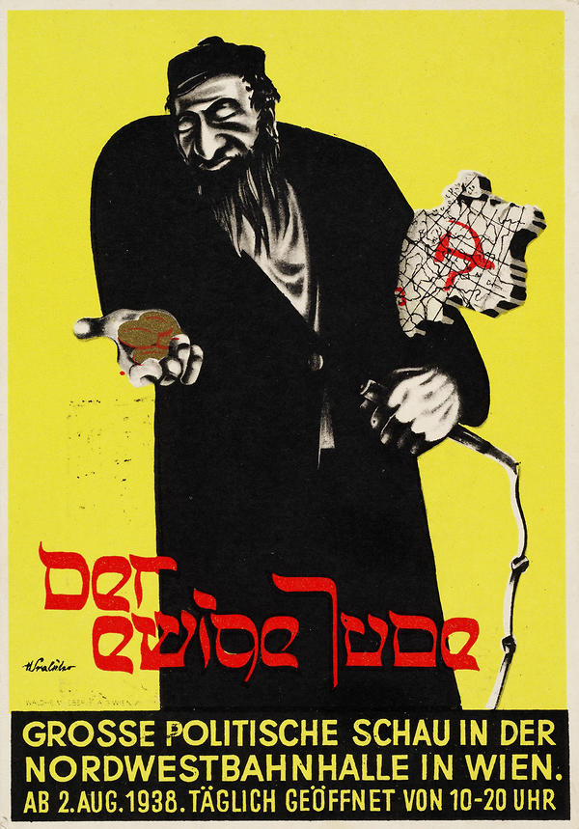
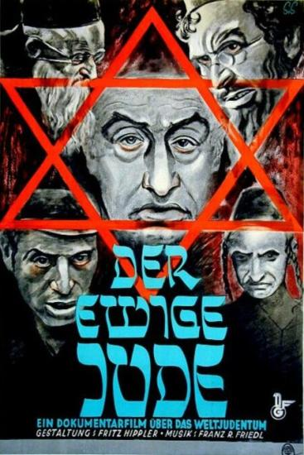

5) Secret Service report on the audience response Der Ewige Jude
Following an extensive publicity campaign in the press and on radio, the documentary film The Wandering Jew has been awaited with great interest by the public, according to reports from all parts of the Reich. Numerous reports indicate that audiences are saying over and over again that the film's visual documentation, with its broad panorama of Jewish life and affairs, has completely lived up to these high expectations and that the film is more instructive, convincing and impressive than many an anti-Jewish tract. There has been unanimous acknowledgment of the high standards achieved in collating the available material into a single unit. Particularly favourable comment was made - as reported from Munich, Koblenz, Schwerin, Danzig, Halle, Konigsberg, Potsdam and Berlin - on the way the maps and statistics catalogued the spread of Jewry (the comparison with rats is mentioned as particularly impressive) and its expanding influence on all areas of life and in all countries of the world. The shots of Jews in America have prompted particular comment. People were surprised by the open revelations of the Jewish influence in and dominance of the USA (Schwerin, Karlsbad). Particularly impressive were thought to be the scenes in which Jews were shown 'in their original state' and 'in European fashion' as men of the world (Leipzig), and in general the juxtapositions (Jewish ghetto - parade of German youth at the Party Rally) were thought to make an extraordinarily telling effect. According to a report from Munich, there was immediate relief and enthusiastic applause at the point in the film when the Führer appears and in his speech announces that a new war can only bring about the final annihilation of Jewry. Throughout the film the sequences describing the history of the Rothschild family, and in particular the information that members of the family had been naturalized in a number of different countries, thus establishing themselves as recognized citizens of the most important countries, were notably effective and convincing. These sequences and the contrasting of Jewish types from all parts of the world provided devastating proof - as can be deduced from numerous conversations -that for all his apparent adaptation to countries, languages and ways of life, a Jew is always a Jew.
Because of the very intensive publicity for the film and its impressive organization of documentary evidence, the first performances produced remarkably high audience figures. But in some places audience interest has often soon fallen off, because the film has followed too quickly on the feature film Jud Süss. Since a large part of the population had already seen Jud Süss, it was very often assumed - according to the information to hand - that the documentary film The Wandering Jew had nothing really new to say. Reports received from, for example, Innsbruck, Dortmund, Aachen, Karlsruhe, Neustadt/Weinstrasse, Bielefeld, Frankfurt am Main and Munich all agree that it is often only the politically active sections of the population who have seen the documentary film while the typical film audience has largely avoided it, and that in some places there has been a word-of-mouth campaign against the film and its starkly realistic portrait of the Jews. The repulsive nature of the material and in particular the ritual slaughter scenes are repeatedly cited in conversation as the main reason for not seeing the film. The film is repeatedly described as an exceptional 'strain on the nerves' (Neustadt/Weinstrasse). This is why attendance figures fell very sharply in places, particularly in North West, West and South Germany and in the Eastern region [i.e. Austria]. According to reports from West Germany and from Breslau, people have often been observed leaving the cinema in disgust in the middle of a performance. Statements like 'We've seen Jud Süss and we've had enough of Jewish filth' have been heard. There have been isolated cases of women and even young men fainting during the ritual slaughter scenes. People have frequently claimed that Jud Süss had shown such a convincing picture of Jewry that this new and even more blatant evidence, following immediately after it in this documentary film, served no further purpose. On the other hand, numerous statements have been reported, particularly from the politically active sections of the population, expressing considerable appreciation of the film as a remarkably impressive document.

Images: http://www.dhm.de/lemo/objekte/pict/96003766/ http://www.dhm.de/lemo/objekte/pict/96003766/
Text: Arthur Marwick and Wendy Simpson (eds.): Primary Sources 2: Interwar and World War I. Milton Keynes 2002 [2001]; http://www.holocaust-history.org/der-ewige-jude/program.shtml

