Chapter 1: First Steps
Start Eclipse.
Import the Eclipse project scenarios-chapter-1.
Go to the src/scenario01… subfolder. The scenario includes a file MyKara.java. Files ending in .java Include program code.
Now open the file MyKara.
In this file there are two blocks, called methods, with names act() and main (...) and a few blue comments. The main method is needed so that the computer knows where the program begins. For now, we’ll only need the act() method.
To start, we press the "Run" button in Eclipse:
A window opens and the scenario similar to the following figure should appear:
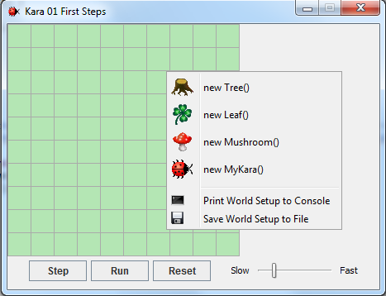
Context menu
(right-click)
Controls
World

- The world: The largest area is called world. This is the area when the program runs, we can see what happens. In the Kara scenario it is a green meadow with gridlines.
- The context menu: With the context menu we can set new actors into the world.
- The controls: The buttons Act, Run, and Reset and the speed slider at the bottom serve the controlling of the program. We will come to that later.

Classes and Objects
For our projects we use the Java programming language. Java is a so-called object-oriented language. For object-oriented programming, the concepts of classes and objects are of fundamental importance.
Consider the class MyKara. MyKara is the class for the general concept of a beetle - so to speak, it is like a blueprint from which we can create individual beetles. The produced beetles are called objects (or instances).
With the mouse we create new objects as follows: Right click on the green world and choose menu item new MyKara (). Objects can also be moved around using the mouse.
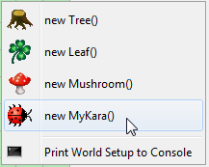
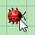

Task 1:
Create an object of Kara. Create several objects of the leaves.

Interacting with Objects
To interact with objects in the world, we click with the right mouse button to bring up the object menu. The object menu of Kara shows us what Kara can do. These operations are called methods in Java.
Task 2:
- What does the move() method do?
Kara moves ahead one field.
- Place two Karas in your world and make sure that they face each other. Which method do you need?
turnLeft() or turnRight()

- Try the other methods. There are two types of methods. What are those types and what do they do?
Methods with void: Perform an action.
Methods with boolean: Open a window containing the methods result.

Return Types
The word in front of a method name is also referred to as the return type. It tells us what the method returns, if we call it. The word void in this case means “nothing” - they return nothing, just perform an action.
If instead of void anything else is stated, we know that our method returns a result and also what type of result. The boolean type has two possible values: true or false. Then there are a number of other types which we will discuss later.

Task 3:
- Right-click on the Kara object and call the onLeaf() method. Does it always return false? Or are there situations where it returns true?
If Kara is on a leaf this method returns true.
- Add a tree to the world. What method can you call to check if Kara is facing a tree?
treeFront()
- What happens if you call Kara’s move() method when Kara is facing a tree?
Kara complains that he can’t move.

Object State
If we right-click on a Kara-object, then select inspect, we can determine the state of the object.
Task 4:
What are the values of the coordinates and rotation in the following situations?
a) 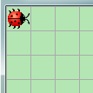 | b) 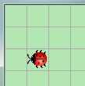
x: 0  y: 0  rotation: 0 | x: 1  y: 2  rotation: 180

Note: The first field in the top left corner has the coordinates (0, 0) and NOT (1, 1)!

Running Programs
So far we have only interacted with the objects using mouse-clicks. But there is another possibility, namely by writing programs.
Task 5:
- Place a MyKara object into your world. What does the method act() do?
move, turn right, move
- What happens if you press the Step button?
The same as before, the act() Method is called
- Click on the Run button. What is happening? Try using the slider.
act() is called again and again until the pause button is clicked

Source Code
We have just used the act() method. Now let's see where the behavior of this method is programmed. For this we need to open the source code in the Eclipse editor:
Open the class MyKara with a double click.
The source code is written in Java and contains all the details about a class and its objects. For the moment we are only interested in the part where the method act() is defined. Here, the three commands: move(), turnRight() and move() are called. You can now modify and extend these commands.
When you have made some changes you will notice that the class is shown with a little star in the tab. This is an indication that the class has been modified and has not been saved yet. Save the changes (ctrl-s).
Each time you save the class Eclipse automatically translates it (or technical terminology: compiles). The compiling is a process of translation: The source code of the class is translated into machine code that can be executed by the computer.
The Translation Process (Compiling)
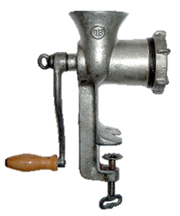
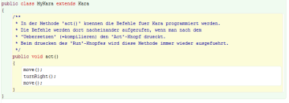
Human readable
source code
Machine readable
code

Compiler

Task 6:
Go to the Scenario 06 in src/scenario06_putting_leaf. Open in Scenario 06 the file MyKara.java.
Change the content of the act() method so that Kara makes a step first, then puts a leaf down and takes a step again. (At the beginning of the class you will find a comment describing all the actions that Kara can perform.)
Note: After each command we must include a semicolon!
Task 7:
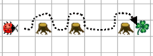
Open the Scenario 07. If you start MyKara you should automatically see the world as shown to the right:
Note: The world is loaded from the text file WorldSetup.txt. This filename is defined in the main()-Method inside MyKara.

Now write a program that takes Kara to the leaf along the dotted line on the image above. He will have to run around the trees. Arriving at the leaf, he should pick it up.

Kara gets new Methods
Task 8:
If you have solved task 7 correctly your program should contain three equal parts, namely for walking around each tree. We can expand our program for clarity by introducing a new method. Below the act() method we will create a new method:
public void goAroundTree() {

}

Between the curly brackets of the method, write the commands to make it go around a tree.
Now use the new method goAroundTree() inside the act() method for each of the three trees.

The worksheets in this chapter are based on the book “Introduction to Java using Greenfoot” by Michael Kölling (2010). Ideas and concepts of Kara were developed by Jürg Nievergelt, Werner Hartmann, Raimond Reichert et al. http://www.swisseduc.ch/informatik/karatojava/, February 2011.

