Greenfoot Installation
Greenfoot requires the Java 6 JDK (or above).

Installing Java
The Java download can be found on the following website:
http://www.oracle.com/technetwork/java/javase/downloads/
Note that you need the version marked JDK not JRE.
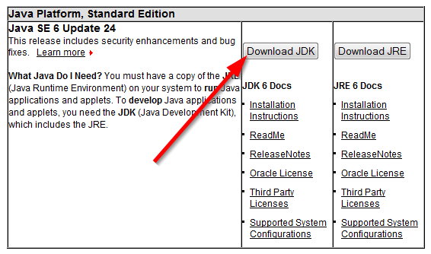

Installing Greenfoot
The Greenfoot software can be found on the following website:
http://www.greenfoot.org/download/
Choose the version for your operating system and install it.

