Solarzellen und Fotosynthese

1. Einführung
Die Speicherung von Lichtenergie ist sowohl in der Biologie, als auch in der Technik von überragender Bedeutung. Die Fotosynthese liefert die Energie für die Lebensfunktionen sämtlicher Lebewesen – und die Fotovoltaik wird in Zukunft gewaltig an Bedeutung zunehmen, um im technischen Bereich Energie zu gewinnen, ohne durch CO₂-Emissionen die Gefahr der Klimaerwärmung zu erhöhen.
Im folgenden werden Sie durch den Vergleich der Si-Solarzelle, der TiO2-Solarzelle und der Fotosynthese Gemeinsamkeiten und Unterschiede erarbeiten – mit dem Ziel, Vor- und Nachteile dieser Vorgänge kennen zu lernen.

2. Nachteile der Si-Solarzelle
Nennen sie zur Repetition die beiden wichtigsten Nachteil der Silizium-Solarzelle in bezug auf die Lichtabsorption und die Ladungstrennung:

1.

2.

3. Vergleich der TiO₂-Solarzelle mit der Fotosynthese
Da wir uns noch vertieft der Fotosynthese widmen werden, lohnt es sich, einen Überblick über die Fotosynthese zu gewinnen.
Dazu werden Sie nach Anleitung der Lehrperson das folgende Schema zur Fotosynthese ergänzen.

Schema der Fotosynthese
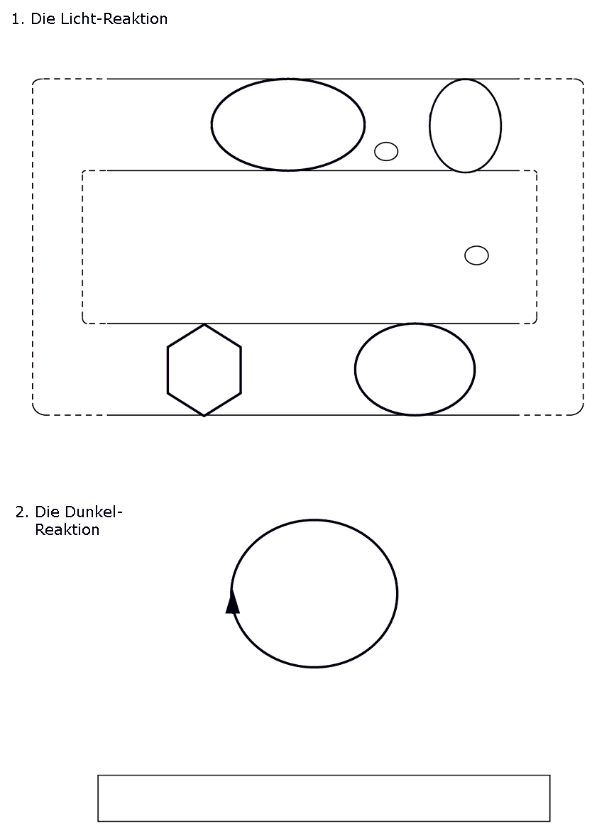
Lesen Sie den folgenden Artikel von Michael Graetzel, der die TiO₂-Solarzelle an der ETH in Lausanne entwickelt hat. Es geht dabei um den Vergleich seiner Solarzelle mit der Fotosynthese. Anschliessend sollten Sie in der Lage sein, die Fragen im Anschluss an den Artikel zu lösen.

" Electron Transfer in Chemistry " Vol. 5, Section 3 (Excerpt)

Solar Energy Conversion

Michael Grätzel and Jacques-E. Moser
Laboratory for Photonics and Interfaces Institute of Physical Chemistry
Swiss Federal Institute of Technology CH 1015 Lausanne Switzerland

Introduction

In a conventional p-n junction photovoltaic cell made, for example, of silicon, the semiconductor assumes two roles simultaneously: It harvests the incident sunlight and conducts the charge carriers produced under light excitation.
In order to function with a good efficiency, the photons have to be absorbed in the vicinity of the p-n interface. Electron-hole pairs produced away from the junction must diffuse to the p-n contact where the local electrical field separates the charges.
To avoid charge carrier recombination during the diffusion, the concentration of defects in the solid must be small. This imposes severe requirements on the purity of the semiconductor material, rendering solid state devices of the conventional type quite expensive.
Molecular photovoltaic systems separate the functions of light absorption and carrier transport. Light harvesting is carried out by a dye-sensitizer which initiates electron transfer events leading to charge separation. This renders unnecessary the use of expensive solid state components in the system. While being simple from the conceptual point of view, the practical implementation of such devices must overcome several serious obstacles if the aim is to develop molecular systems which convert sunlight to electricity at an efficiency comparable to that of silicon cells, and meet the stability criteria for practical applications.

Mimicking Natural Photosynthesis

Natural photosynthesis is the most important of the many interesting photochemical processes known in biology. Not only was the evolution of the Earth’s atmosphere dependent on it, but also it is the main route by which the free energy of the environment is made available to the living world. Green plants, algae and cyanobacteria make use of sunlight to drive a thermodynamically uphill reaction, the reduction of carbon dioxide to carbohydrates by water.

6 CO₂ + 6 H₂O → C₆H₁₂O₆ + 6 O₂

The input chemicals are carbon dioxide and water, while the output is oxygen and carbohydrates. The latter serve as a feed stock for other organic products such as wood, coal, oil and gas constituting the world’s fossil fuel reserves.
Most of the key features of how photosynthetic energy conversion operates are known by now. Light induced charge separation is achieved through judicious spatial arrangement of the pigments and elements of the electron transport chain in the tylakoid membrane. Co-operative interaction between these components allows the electron transfer to proceed in a vectorial fashion. Although strategies to design artificial photoconversion devices should not attempt to blindly imitate all the intricate of natural photosynthesis, it is inconceivable to accomplish the challenging task of converting visible light into electrical work or chemical potential without suitable engineering on the molecular level. Efficient molecular photovoltaic devices use similar concepts as green plants to harvest and convert solar energy. It is therefore useful to review the important features of their natural analogue.
The essence of natural photosynthesis is the use of photochemical energy to split water and reduce CO₂. Molecular oxygen is evolved in the reaction. Photochemical processes produce compounds of high chemical potential, which can drive a multi-step synthetic sequence from CO₂ to Glucose in a cyclic way. The overall reaction is thermodynamically very endergonic in the dark (∆G° = 522 kJ per mole of CO₂ converted).
Photosynthesis comprises a light-induced and a dark reaction. The first, called photophosphorylation, involves the two-electron reduction of NADP+ by water, to produce NADPH and oxygen. The redox reaction is coupled to the generation of adenosine triphosphate ATP from adenosine diphosphate ADP (Fig. 1).

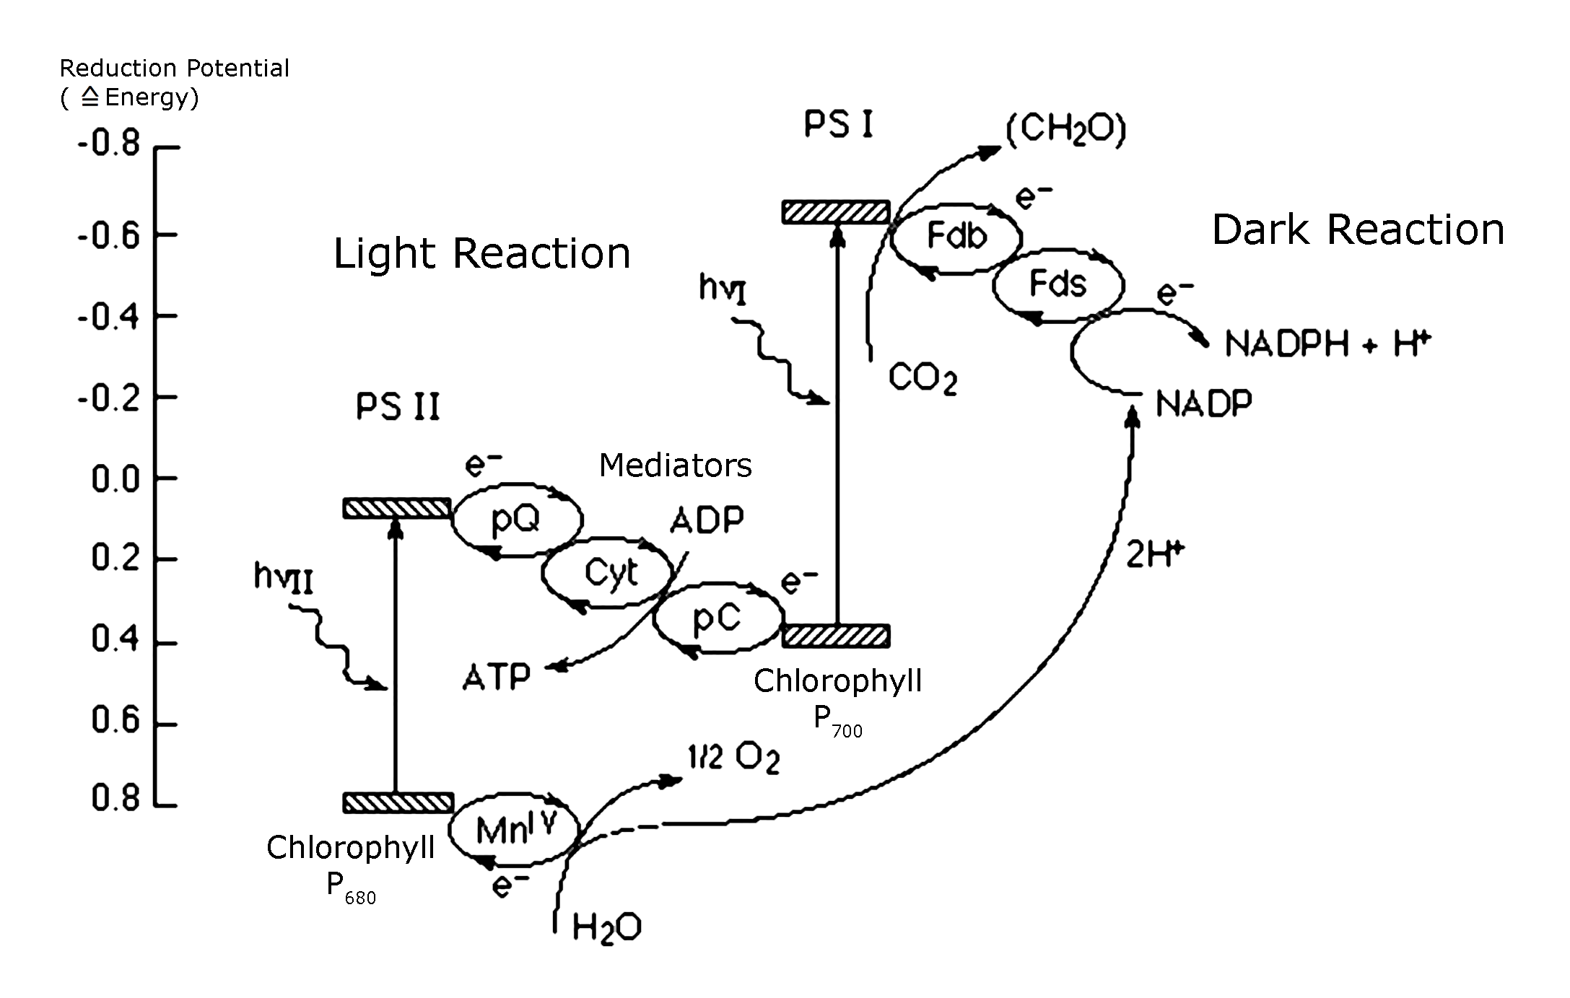
Fig 1: The Z-scheme of photosynthesis: coupling of the two pigment systems, PS II and I.
pQ = plastoquinone; Cyt = cytochrome; pC = plastocyanine; Fd = ferrodoxine.
This light-driven reaction takes place in the tylakoid membranes located in the interior of the chloroplasts of plant cells. The photosynthetic unit assembled in these membranes is composed of antenna pigments for light energy harvesting, i.e. chlorophyll and carotenoids, as well as a reaction center consisting of two photosystems, called PS I and PS II. Photoexcitation of PS II results in the transfer of the excited electron to plastoquinone (pQ). This product is the electron donor for PS I which performs the reduction of NADP+ to NADPH – the universal carrier of electrons in the cell, which is used in the dark reaction for the production of glucose.
The photons absorbed in the PS II by the antenna pigments are transferred to a chlorophyll dimer that is part of the reaction center. The photochemical excitation causes electrons to be ejected from the chlorophyll dimer and then passed on to various electron-transferring mediators.
The spatial arrangement of these components allows the electrons to be transferred in a vectorial fashion from the inner to the outer part of the membrane. By this, the recombination of the excited electron is avoided and the reaction gets irreversible.
This aim is achieved by two means: On the one hand the transfer of the excited electron to the first mediator is faster than the recombination, on the other hand, the mediator with the excited electron moves away by diffusion (Fig. 2).

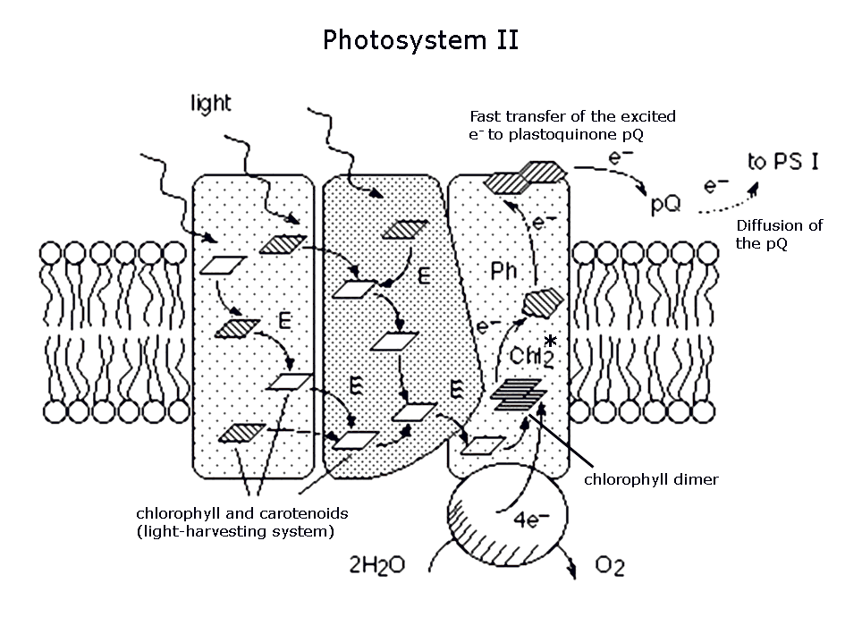
Fig 2: Functional organization of photosystem II in protein-complexes contained in the thylakoid membrane. Excitation energy is harvested by chlorophyll and carotenoid molecules and transfered to the special pair (Chlorophyll Dimer). Vectorial electron transfer across the membrane takes place from excited Chl₂* to plastoquinone (pQ) via pheophitine (Ph) and quinone (Q) electron mediators.

In the TiO₂- photovoltaic device, the incident photons excite a dye-sensitizer that injects quickly an electron into the conduction band of TiO₂, a wide bandgap semiconductor. The missing electron of the dye is replaced by an electrolyte mediator which undergoes diffusion between the cathode and the dye (Fig. 3)
Mimicking the key features of natural photosynthesis, these devices rely on a porous structure to ensure efficient harvesting of sunlight using a molecular dye absorber. As well, light absorption and electron collection functions are separated in such systems. Electron injection into semiconducting TiO₂-nanoparticles which achieves charge separation across the solid/electrolyte interface is analogous to charge separation in the photosynthetic membrane: The injection is faster than the recombination - and by the diffusion of the mediator, the process gets irreversible as well.

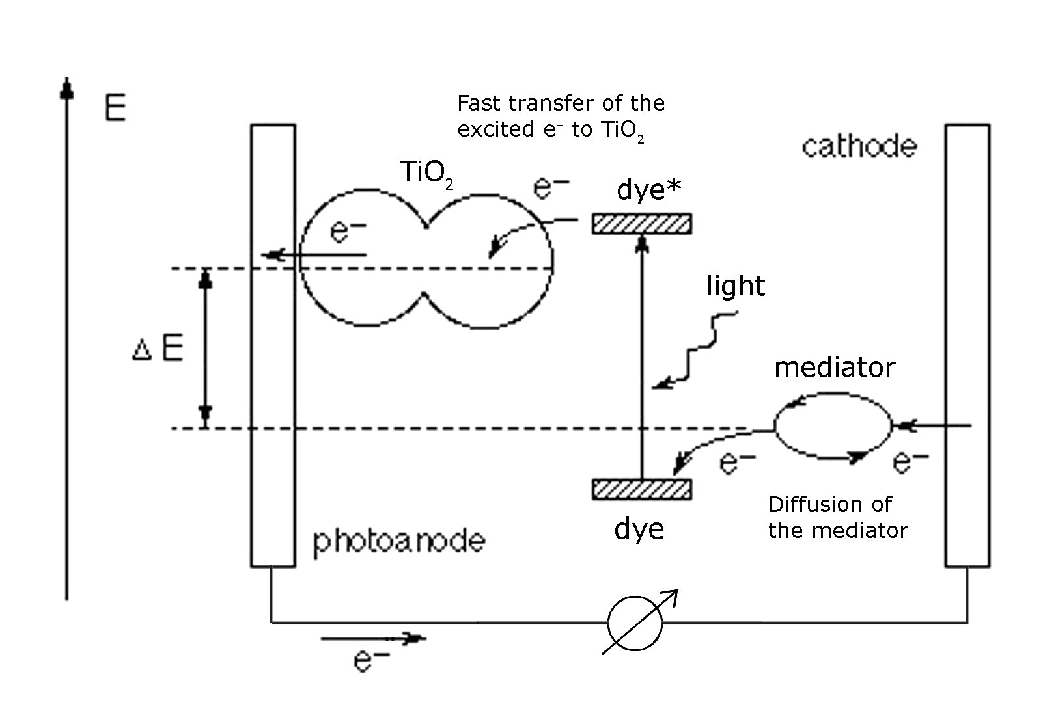
Fig 2: Schematic representation of the principle of the TiO₂ photovoltaic cell showing the electron energy level in the different phases. The cell voltage ∆V obtained in the presence of light corresponds to the difference in the high electrochemical potential of the excited TiO₂ and the lower electrochemical potential of the mediator. The recombination of the electron is prevented by fast injection of the excited electron in TiO₂ and the diffusion of the mediator.

Aufgaben: Vergleich von Fotosynthese und TiO2-Solarzelle

a) Wo findet die Elektronenanregung statt?

Fotosynthese | TiO₂-Solarzelle

b) An welche Stoffe werden die angeregten Elektronen weitergegeben, und woher stammen die Elektronen für den Ersatz?

Fotosynthese | TiO₂-Solarzelle

b) Nach welchen Prinzipien findet die Ladungstrennung statt?

Fotosynthese | TiO₂-Solarzelle

d) Vergleichen Sie das chemische Schicksal des angeregten Elektrons:

Fotosynthese | TiO₂-Solarzelle

e) Jetzt sollte es Ihnen nicht schwer fallen, auch die wichtigsten Unterschiede zwischen der Fotosynthese und der TiO₂-Solarzelle festzuhalten

 | Fotosynthese | TiO₂-Solarzelle
energetisch
chemisch

4. Vergleich der Si-Solarzelle mit der TiO₂-Solarzelle

a) Nennen und erläutern Sie zum Schluss noch kurz die wichtigsten Vorteile der TiO₂-Solarzelle im Vergleich zur Si-Solarzelle. Halten Sie sich dabei an die zu Beginn erwähnten Nachteile der Si-Solarzelle.

