Batteries

Group work according to the Puzzle Method:
Documentation for the expert groups

Part 1: Nickel-Metal-Hydride Batteries
Part 2: Lithium Batteries
Part 3: Lithium-Ion Batteries
Part 4: Fuel Cells

Instructions

In the expert group:
• Read the text on the nickel-metal-hydride battery carefully; answer the questions and do the exercise. Discuss the text and any questions which arise as a group. Make sure that all group members understand how such a battery works, including all the described chemical reactions.
• Prepare for the task you will have to do in the exchange groups together. Find the best way to present what you have read, emphasizing the central points (which include the processes at the electrodes and in the electrolyte). Every group member must be able to explain the content of the text, including all chemical reactions, so that his or her listeners will understand it.
In the exchange groups:
When your turn comes:
• Present your topic to the other group members.
• Answer your class-mates' questions. Make sure that they understand what you are explaining.
When you are listening to your class-mates' presentations:
• Take written notes (in English of course) so that you will be able to revise the matter later on (e.g. when learning for a test).

Nickel-Metal-Hydride Batteries
Nickel-metal-hydride ("NiMH-") batteries are the most common rechargeable batteries used for devices such as portable music players, phones, cameras, electric toothbrushes, razors, torches etc. They are available in the same sizes as alkaline batteries and are interchangeable with them, but they are also incorporated in some devices or in their battery packs.
In order for the battery to be rechargeable, its electrode reactions are designed to generate solid products adhering to the electrodes and therefore being available for the reverse reaction when the battery is recharged.
When the battery is discharged, the following reduction takes place at the positive electrode:
[1] NiO(OH)(s) + H₂O(l) + e– → Ni(OH)₂(s) + OH–(aq)
Questions:
a) Of which ions do the compounds NiO(OH) and Ni(OH)₂ consist?
b) Which element is reduced in reaction [1]? What is its oxidation state on the left and right side of the equation?
c) What is the role of H₂O in reaction [1]?
The electrolyte is a concentrated aqueous solution of KOH, providing H₂O for the discharge reaction and OH– for the reverse (recharge) reaction.
The nickel-metal-hydride battery is a new development. Its precursor was the nickel-cadmium ("nicad-") battery. Both battery types use the same reduction reaction, but the oxidation is different. In the nickel-cadmium battery, cadmium is oxidized. Cadmium and its compounds are very toxic and as a result, batteries containing cadmium pose a threat to the environment, if they are not properly disposed of. In the nickel-metal-hydride battery, hydrogen is used instead of cadmium as a reducing agent, which makes this battery environmentally safe:
[2] H₂ + 2 OH– → 2 H₂O + 2 e–
The problem with hydrogen is that it is a gas. It can be stored under pressure in gas cylinders or as a liquid at very low temperatures - both impossible ways to use in a small commercial battery. But in recent years, metal alloys have been developed which can absorb hydrogen in high concentrations (1 cubic centimetre of such a metal hydride contains more hydrogen than 1 cubic centimetre of liquified hydrogen). Much research is done nowadays on hydrogen storage compounds, intending to use them not only in batteries, but also in future cars fuelled by hydrogen.
Most nickel-metal-hydride batteries use an alloy containing mainly lanthanum (together with other lanthanides like cerium and praseodymium), nickel and some other metals (e.g. cobalt). The main hydrogen storing agent in these alloys is LaNi₅. When fully loaded with hydrogen, it becomes LaNi₅H₆. Such a compound of metal and hydrogen is called a metal hydride. With hydrogen stored in the form of this metal hydride, reaction [2] becomes
[3] LaNi₅H₆(s) + 6 OH–(aq) → LaNi₅(s) + 6 H₂O(l) + 6 e–
This reaction equation is a simplification, since - as stated above - the storage alloy is not just LaNi₅, but has a more complicated composition.
Again (as in reaction [1]) the electrolyte provides OH– and H₂O for the discharge and recharge reaction respectively.
Exercise: Write down the equations for the discharge reactions: for the oxidation (at the negative electrode) and the reduction (at the positive electrode), and combine them to the overall reaction:

Oxidation:

Reduction:

Overall reaction:

The opposite figure shows the construction of a nickel-metal-hydride battery, which ensures large electrode surfaces and short ion migration paths. Between the negative electrode (containing the metal hydride) and the positive electrode (made of nickel oxyhydroxide) there is a separator soaked with the electrolyte (potassium hydroxyde solution).
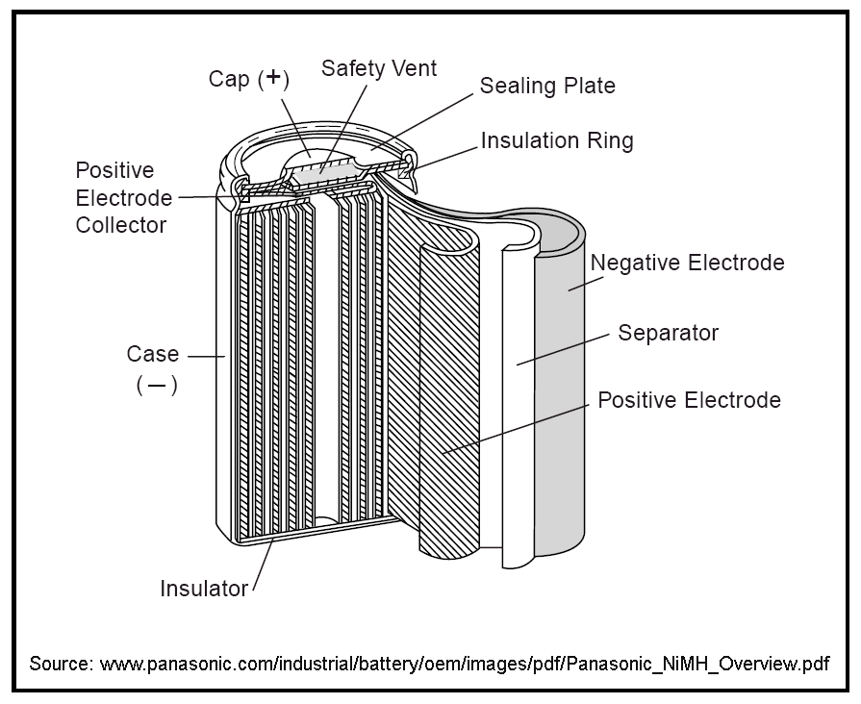
The voltage of a nickel-metal-hydride cell is 1.2 V. This is somewhat less than the 1.5 V of an alkaline battery. But almost all devices powered by batteries can cope with this voltage difference, so that nickel-metal-hydride batteries can be used instead of alkaline cells. They have the advantage of being rechargeable, but the disadvantage of high self-discharge (which means that they lose energy even without being used). No battery is free of self-discharge, but with nickel-metal-hydride batteries the energy loss is higher than with other battery types - about 1% per day.
As is the case for every rechargeable battery, recharging is not ad infinitum. The capacity of a nickel-metal-hydride battery decreases during its lifetime, which is limited to about 300 to 1000 discharge-recharge cycles. Therefore, it should not be charged unnecessarily, but only after using most of its energy content.
Nickel-metal-hydride batteries should be recycled, not because of toxic contents, but because the lanthanides they contain constitute a limited resource.

Answers to the questions:
a) NiO(OH) consists of Ni³⁺, O^{2–} and OH–; Ni(OH)₂ consists of Ni²⁺ and 2 OH–.
b) Nickel is reduced from Ni(+III) to Ni(+II).
c) H₂O acts as an acid, protonating O^{2–} to become OH–, thereby compensating for the change in charge of the Nickel ion and leading to the product Ni(OH)₂, which is insoluble and therefore adheres to the electrode.

Solution of the exercise:
Oxidation: LaNi₅H₆(s) + 6 OH–(aq) → LaNi₅(s) + 6 H₂O(l) + 6 e–
Reduction: 6 NiO(OH)(s) + 6 H₂O(l) + 6 e– → 6 Ni(OH)₂(s) + 6 OH–(aq)
Overall reaction: LaNi₅H₆(s) + 6 NiO(OH)(s) → LaNi₅(s) + 6 Ni(OH)₂(s)

Instructions

In the expert group:
• Read the text on lithium batteries carefully; answer the question and do the exercise. Discuss the text and all the questions which arise as a group. Make sure that all group members understand how such batteries work, including all the described chemical reactions.
• Prepare for the task you will have to do in the exchange groups together. Find the best way to present what you have read, emphasizing the central points (which include the processes at the electrodes and in the electrolyte). Every group member must be able to explain the content of the text, including all chemical reactions, so that his or her listeners will understand it.
In the exchange groups:
When your turn comes:
• Present your topic to the other group members.
• Answer your class-mates' questions. Make sure that they understand what you are explaining.
When you are listening to your class-mates' presentations:
• Take written notes (in English of course) so that you will be able to revise the matter later on (e.g. when learning for a test).

Lithium Batteries
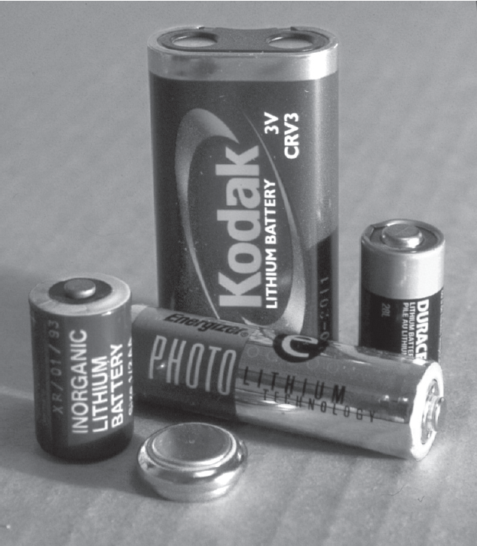Primary (i.e. non-rechargeable) lithium batteries have the highest energy density of all batteries. They provide about three times more electric energy than an alkaline cell of the same size. Their self-discharge is extremely low - they can be stored for more than ten years. Furthermore they can be used at very low and high temperatures, when most other battery types fail. These advantages have their price - lithium batteries are the most expensive ones among the commonly used primary batteries.
They are used in watches, calculators and cameras. As back-up batteries in computers, they are sometimes mounted onto a circuit board with no possibility of being replaced, because their lifetime exceeds that of a computer. Their long lifetime and high reliability are also the reason for their use in heart pacemakers. Most lithium batteries have a voltage of 3 to 4 volts, depending on the composition of the positive electrode, but nowadays 1.5 V cells are also available which are interchangeable with alkaline cells.
Lithium does not only have the lowest density of all metals, it also can provide the highest number of electrons per gram when it is oxidized:
Question: To get one mole of electrons by oxidation - how many grams of lithium are needed? How many grams of zinc? Of lead?
Furthermore, lithium is the strongest reducing agent. The voltage of a battery depends on the strength of the reducing and oxidizing agents. Therefore, for a given oxidizing agent in the positive electrode, a negative electrode of lithium will yield the highest possible voltage.
Since the amount of energy stored in a battery depends on the number of electrons transferred and the voltage, lithium is the ideal material for a negative electrode regarding the energy density of the battery.
However, lithium cannot be used together with an aqueous electrolyte, since it would react with water producing hydrogen gas:
Li(s) + H₂O(l) → Li⁺(aq) + OH–(aq) + ½ H₂(g)
Like water, all other solvents which can provide protons (so called "protic" solvents) cannot be used in lithium batteries. Suitable solvents have to be "aprotic", but they also have to be polar enough to dissolve salts, which are needed for the necessary electrical conductivity of the electrolyte. Different organic solvents meet these requirements; most often a solution of lithium perchlorate in propylene carbonate (see opposite formula) is used as electrolyte.
propylene carbonate - a polar, aprotic solvent
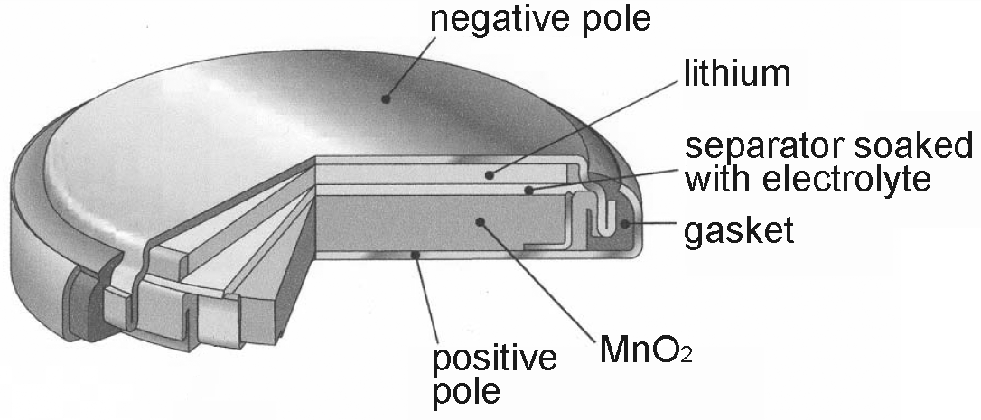The opposite figure shows the structure of a miniature lithium battery using manganese(IV) oxide as oxidizing agent in the positive electrode. In contrast to the alkaline battery, which uses the same oxidizing agent, the electrolyte of the lithium battery - being aprotic - cannot provide protons to produce MnO(OH). But it contains Li⁺ ions which are small enough to move into the manganese oxide lattice producing LiMnO₂ and thereby ensures the charge balancing.
Exercise:
a) Determine the oxidation state of manganese in the reactant and product of the oxidation reaction.
b) Write down the equations for the oxidation at the negative electrode and the reduction at the positive electrode and combine them to obtain the overall reaction equation:

Oxidation:

Reduction:

Overall reaction:

Vocabulary:
back-up battery Pufferbatterie
circuit board Platine
heart pacemaker Herzschrittmacher
protic protisch
aprotic aprotisch
miniature battery Knopfzelle
charge balance Ladungsausgleich

Answers to the question:
For 1 mol e– you need
• 1 mol Li = 6.94 g
• 0.5 mol Zn = 32.70 g
• 0.5 mol Pb = 103.60 g

Solution to the exercise:
a) Mn(IV) in MnO₂; Mn(III) in LiMnO₂
b) Oxidation: Li(s) → Li⁺(solv) + e–
Reduction: MnO₂(s) + Li⁺(solv) + e– → LiMnO₂(s)
Overall reaction: Li(s) + MnO₂(s) → LiMnO₂(s)

Instructions

In the expert group:
• Read the text on the lithium-ion batteries carefully. Discuss the text and all the questions which arise as a group. Make sure that all group members understand how such batteries work.
• Prepare for the task you will have to do in the exchange groups together. Find the best way to present what you have read, emphasizing the central points (which include the processes at the electrodes and in the electrolyte). Every group member must be able to explain the content of the text, including all chemical reactions, so that his or her listeners will understand it.
In the exchange groups:
When your turn comes:
• Present your topic to the other group members.
• Answer your class-mates' questions. Make sure that they understand what you are explaining.
When you are listening to your class-mates' presentations:
• Take written notes (in English of course) so that you will be able to revise the matter later on (e.g. when learning for a test).

Lithium-Ion Batteries
Lithium-ion batteries have the highest energy density of all rechargeable batteries. They do not store much more energy than a nickel-metal-hydride battery of the same size, but they are much lighter. Another advantage is that they lose very little energy when stored without being used (i.e. their "self-discharge" is low). But they are quite expensive. They are mainly used in portable computers, mobile phones and video cameras.
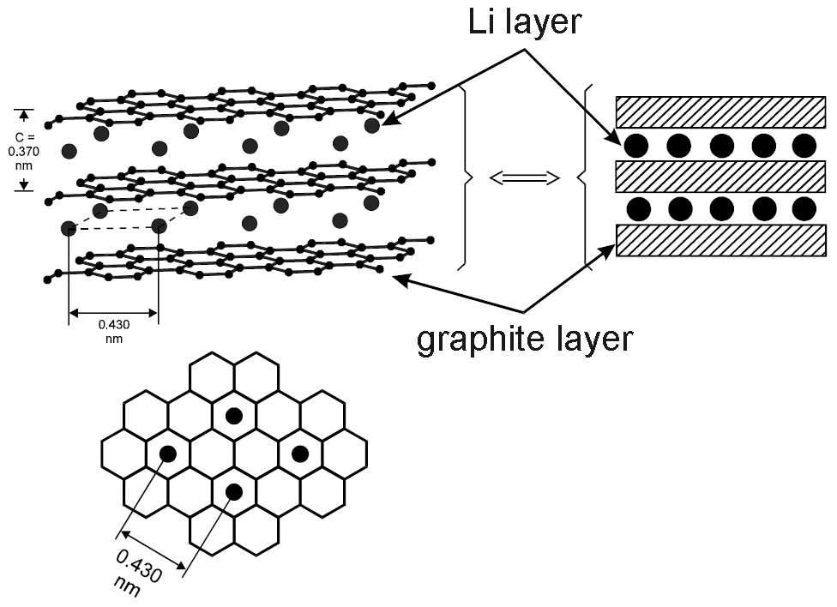The negative electrode of the charged lithium-ion battery is a so-called intercalation compound of lithium and graphite. The cores of the lithium atoms (i.e. the atoms without their outer electron, the lithium ions) occupy positions between the graphite lattice layers (see figure). For every Li⁺ ion there is an additional electron bound to a nearby C atom in the graphite lattice, so that the compound is electrically neutral. The compound is not stoichiometric, i.e. the number of Li atoms is variable; the maximum lithium content is 1 Li atom for 6 C atoms.
While the negative electrode is oxidized during discharge of the battery, Li⁺ ions leave it and move into the electrolyte, to compensate for the loss of negative charge. The same number of Li⁺ ions is absorbed by the positive electrode, compensating for its gain of electrons when it becomes reduced. Thus, like in the primary lithium batteries, the charge balance is maintained by Li⁺ ions moving through the electrolyte.
The oxidizing agent in the positive electrode is most often MnO₂ or CoO₂. The Li⁺ ions absorbed during discharge move into its lattice, resulting in an intercalation compound in the positive electrode too.
Like in the primary lithium batteries, the electrolyte is made of a polar aprotic organic solvent (e.g. propylene carbonate), in which LiClO₄ is dissolved. As an alternative, solid polymers are used as electrolytes - in this case the battery is called a lithium polymer battery. Its advantage is, that it cannot leak, and therefore doesn't need a strong containment, which makes it possible to produce batteries in all kind of shapes, including very flat ones.
Intercalation is a reversible process. Therefore, batteries with electrodes made from intercalation compounds are rechargeable.
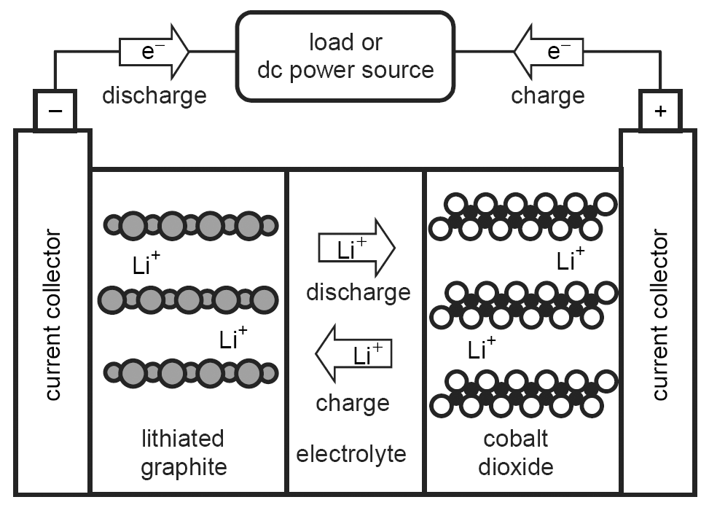The opposite figure schematically shows the processes occurring during discharge and charge in a lithium ion battery with a positive electrode of CoO₂. Its voltage is 3.7 V. The reactions during discharge are as follows (for simplification, the lithium-graphite intercalation compound (= "lithiated graphite") is written as LiC₆, though in reality its lithium content may be lower):
Oxidation: LiC₆ → Li⁺ + 6 C + e–
Reduction: CoO₂ + Li⁺ + e– → LiCoO₂
During discharge, Li⁺ ions move through the electrolyte from the negative electrode to the positive electrode, while during recharge this occurs in the opposite direction.
Regarding the construction, lithium-ion batteries resemble the nickel-metal-hydride batteries: both electrodes form thin sheets; together with a separator containing the electrolyte they are wound up to fit into the battery case.
Lithium-ion batteries do not withstand overcharging, overdischarging and charging too quickly. To prevent these eventualities, electronic security measures have to be taken.

Vocabulary:
intercalation compound Interkalationsverbindung, Einlagerungsverbindung
charge balance Ladungsausgleich

Instructions

In the expert group:
• Read the text on fuel cells carefully and do the exercises. Discuss the text and any questions which arise as a group. Make sure that all group members understand how such cells work.
• Prepare for the task you will have to do in the exchange groups together. Find the best way to present what you have read, emphasizing the central points. Every group member must be able to explain the content of the text, so that his or her listeners will understand it.
In the exchange groups:
When your turn comes:
• Present your topic to the other group members.
• Answer your class-mates' questions. Make sure that they understand what you are explaining.
When you are listening to your class-mates' presentations:
• Take written notes (in English of course) so that you will be able to revise the matter later on (e.g. when learning for a test).

Fuel Cells
Fuel cells are galvanic cells which - unlike batteries - are not self-contained: the reactants are continuously supplied and the products removed during operation. They do not have to be recharged, and there is no self-discharge.
The fuels of such cells can be liquids or gases which flow into the cell and react at the surface of the electrodes. Oxygen is always used as an oxidizing agent at the positive electrode, usually in form of air. The reducing agent is hydrogen in most cases. As an alternative, in some systems methanol (CH₃-OH) can be used, which has the advantage of being liquid and therefore easy to store, but at the expense of lower efficiency. Attempts to use methane (CH₄), which is available in the form of natural gas, have not yet led to practical solutions.
The problem with hydrogen is its gaseous state. To store it in a reasonable volume, there are three possibilities: High pressure, which needs heavy tanks bearing that pressure; very low temperatures, which need much energy for cooling to maintain the low temperature; and compounds storing hydrogen (as used in the nickel-metal-hydride batteries), which are too expensive or not efficient enough at the present stage of development. Therefore, in many cases a chemical reactor is associated with the fuel cell which produces the hydrogen when required by a chemical reaction from a fuel like petrol, methane or methanol. This must not be confused with the direct use of methane or methanol as a reducing agent. - Hydrogen is usually obtained by a reaction of natural gas with water vapour. Alternatively, it can be produced by electrolysis of water using electric energy.
The fuel cell had been invented in 1839, but was of no importance until the 1960s, since when it has been used in space-flights. Submarines are another field of use. - Only in recent years are new applications being developed, which are forecast to play important roles in the future:
• Small local power plants producing electricity for buildings or small settlements. They run at high temperatures (600 to 900 °C); the waste heat is used for heating purposes. They are highly efficient and nearly pollution free, but the energy they produce is still more expensive than that coming from conventional power plants.
• Electric cars. Fuel cells overcome the shortcomings of batteries which are heavy and store less energy. Fuel cell cars use less fuel than conventional cars, do not pollute the air and run silently. Their cells run at temperatures of 70 to 90 °C, using a solid polymer electrolyte.
• The same system used in cars can also be applied to small consumer electronics like mobile computers and phones. Instead of recharging a battery, the tank for the fuel cell has to be refilled with hydrogen or methanol from time to time - thus providing power to the device for a much longer time than a battery would do.
At the negative electrode of a fuel cell, usually hydrogen is oxidized:
[1] H₂ → 2 H⁺ + 2 e–
At the positive electrode, oxygen is reduced, producing water vapour:
[2] ½ O₂ + 2 H⁺ + 2 e– → H₂O
Exercise: Combine these two reaction equations to get the overall reaction equation.
The activation energies of these reactions are much higher than of those occurring in batteries. Therefore, the electrodes must contain catalysts on their surface to speed up the reactions; still fuel cells usually have to run at increased temperature to be efficient. The catalytic substances are alloys of certain metals, mainly platinum and nickel.
Different systems use different electrolytes; among them are alkaline solutions, molten salts, solid ceramics and polymers.
The figure on the next page shows the basic structure of a fuel cell with an electrolyte made of a solid polymer in which protons can move - a so called proton-exchange membrane (PEM). This cell type can be used in cars, as well as in small devices like laptop computers.
Exercise:
The following figure describes a PEM fuel cell. Explain how it works.
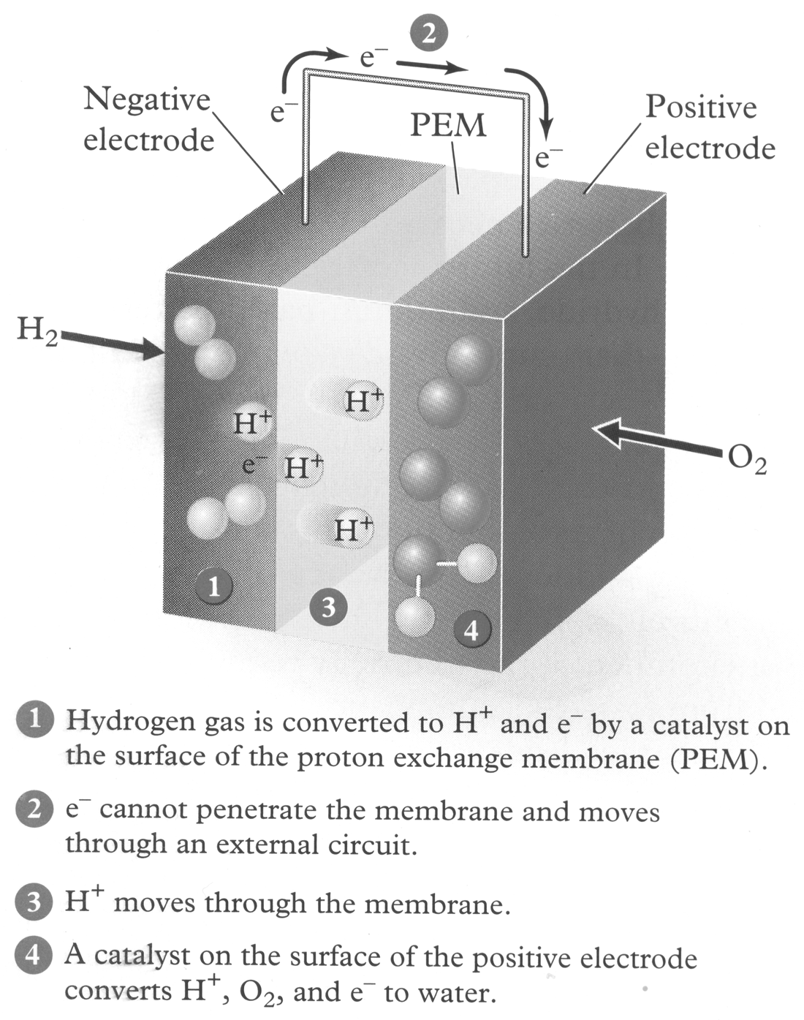

Solution to the first exercise:
The overall reaction is:
H₂ + ½ O₂ → H₂O

An aprotic solvent is one which cannot provide protons (i.e. which cannot function as an acid) . Protic solvents would react with the lithium-graphite intercalation compound.

