Anodising the aluminium body of a pen
(Electrolytic oxidation of aluminium)

1. Theoretical background

The chemistry of aluminium (and its alloys) is interesting. Given that it is a reactive metal (more so than iron) one would expect it to naturally corrode more rapidly than it actually does. The reason it does not is that the initial formation of an oxide layer on the surface protects the base metal underneath. Aluminium oxide is a tough material (its crystallised form is used as an abrasive - Allox), but its formation in air usually results in an amorphous layer with little mechanical strength: a white powder that can easily be scraped off leading to further oxidation.
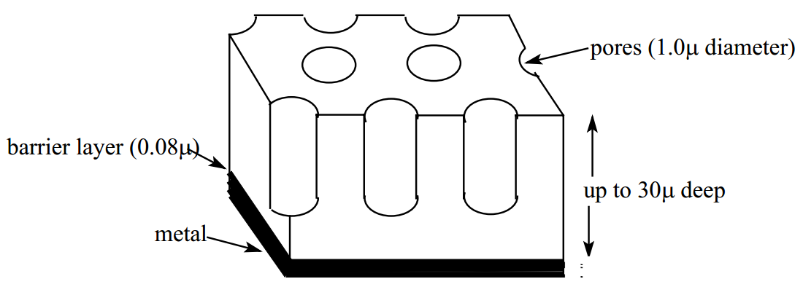
Anodising on the other hand, is a process which forms a particularly structured and dense oxide layer which resists abrasion and thus protects the underlying metal. This layer is colourless, but it is possible to introduce a dye into the pores (see Fig. 1) at one stage in the process to permanently colour the surface. Not all aluminium alloys can be easily anodised, cast aluminium (with high silica content) is particularly difficult.
Figure 1: Structure of an anode layer

2. Safety

Safety
Sulphuric acid solution is a strong acid reagent. If spilled, it should be rinsed with water, and then neutralized with sodium hydrogen carbonate (NaHCO₃). If sulphuric acid gets into your eyes, rinse them in an eye douche for 15 min, consult a doctor.
Contact with skin may cause severe burns. Wear gloves if you touch any wet part of the equipment.
During anodisation caustic aerosols are formed: Set up you apparatus in the hood!

Sodium hydroxide solution is a strong base. Same procedure as for sulphuric acid.

3. Equipment

Power supply, special pen support, alligator clip, 2 cables, 1 L beaker, 2 L beaker, Aluminium sheet serving as cathode, pen body blank, socket and cramp, Al-wire 4 mm, 2 L of sulphuric acid (approx. 20%).

4. Procedure

- The Al-wire is firmly attached to the pen body blank.
- To clean it, the pen body is put for 1 minute exactly into the sodium hydroxide solution (NaOH_{aq}), rinsed for at least 1 minute with flowing tap water, dipped for 10 seconds into nitric acid (HNO₃) and then again rinsed for 2 minutes with flowing tap water.
From here on you may not touch the pen body anymore!
- Set up the apparatus according to the sketch below (Fig. 2). Before you fill up the beaker with sulphuric acid, the aluminium sheet cathode has to be adjusted. It should be closely fitted to the beaker and touch its bottom. The alligator clip is attached to the aluminium sheet on the outside of the beaker as shown in the drawing.
Using a cable the alligator clip is then branched to the negative contact of the power supply. The special support for the body of the pen connects directly to the positive contact.
- Set the current to 0.75 – 0.8 A per pen. The time for the electrolysis is 30 minutes.
- Now choose the dyes which you would like to have on your pen and make sure they are in a beaker and heated to 65°C.
- When the electrolysis is over, rinse the pen under flowing tap water for at least 5 minutes and then with deionised water. Now you are ready to colour your pen. The maximum intensity of the colour is reached after about 5 to 10 minutes.
- To seal the dye put your pen in a beaker containing a boiling seal salt solution. After about 15 minutes the dye is now permanently sealed into the aluminium oxide layer.
Al-wire
pen body support

aluminium
sheet
2L beaker

Figure 2: The setup of the apparatus

5. Disposal

All solutions can be used again. They are poured back into the storage bottles.

6. Lab report

There is no lab report required. But you should understand what you did and be able to explain the chemical reactions that occurred.

